June Newsletter
New Entrance Reminder- There is a new entrance at the back of the school (where the P1-3 children enter and exit. If anyone needs to visit the school or collect their child early (pre-arranged with teacher) please press the buzzer at the new entrance door and Mrs Turley or Miss Mageean will open the door for you. Please remember to wear a face covering and call at the office to explain your visit/collect your child. Many thanks.
Breakfast Club Information: Breakfast Club is open from 8.15-8.50/9am each morning. No children should enter the school building before this time as the school provides no supervision until 8.15am each morning. Cost £1 per day or £4 per week. There will be no breakfast club on Tuesday 22nd June due to P1-5’s school trip to Exploris. Breakfast Club will go ahead on Thursday 17th June for P1-5 children.
Afterschool’s- Actisport I am trying to organise the final sessions the children missed out on before Christmas. Once this is finalised I will let you all know.
Stay and Play-Will finish Stay and Play on Tuesday 29th June.
School Funds This Year:- The school had extra financial constraints this year with Covid. However, we were able to squeeze in a few fundraisers this year. Santa Land- The children in each class attended Santa Land last December. Funds great fully received were £180 but we then had to minus our expenses from this total. We held our annual Christmas Raffle in December and received £309 for school funds which was fantastic after not being able to hold our normal Christmas Plays in the hall. At the beginning of last year we asked for voluntary donations due to the extra mitigations and costs related to getting the school ready due to Covid. We were very thankful to receive £152 in donations. We as a school would like to thank you all for your very kind donations and for supporting our fundraising drives this year under exceptional circumstances this year. These funds raised have went on various parties throughout the year such as the Sacraments, Christmas, purchasing resources etc. for Santa Land, subsiding the P6&7 school trip, Easter Eggs and baskets and other various treats throughout the year.
Learning Support- Mrs O’Hare very kindly offered up her services again this year in order to take a small amount of children out for some additional Learning Support two days a week. We were also lucky this year that all schools were provided with Engage funding and so Mrs O’Hare was able to continue this vital role within our school. We in St. Joseph’s are very grateful for the time she is giving up and her dedication to the school and its pupils once again this year. We are very lucky to have her as part of our team.
Staggered Drop Off’s and Pick Up’s- We have begun the school year with the introduction of staggered drop off and pick up time slots as per government guidance. There is only ten minutes’ difference between slots. The school staff go to the front and back entrances at each time slot in order to safely collect their class group whilst following all sanitiser and hand washing regulations. Please be mindful that the school staff have to stand outside in all kinds of weather so please ensure your child/ren line up at the correct time. We as a school community would appreciate it if all families could wear a face covering whilst on school grounds.
No guidance for September has been issued and therefore we will retain the above arrangements for drop off and pick-ups next year unless we are told otherwise.
Trampoline Area- The trampoline area is on school grounds and even though school teaching time is over for the day, we have noticed some children mixing bubble groups after school. The Government guidelines must be followed by all members of staff and school community as well as visitors whilst on the school site. We would appreciate it if all family groups could follow these guidelines whilst on school grounds and ensure all children are placed safely in their cars at collection times. We are sorry for any inconvenience caused but we are trying our best as a school to keep your children safe and virus free as much as we possibly can at this time.
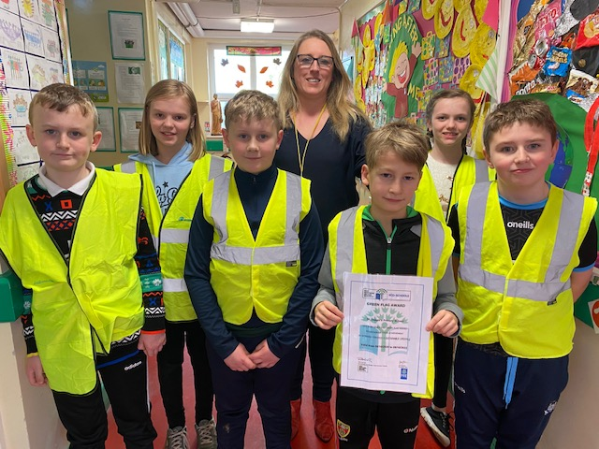
Lunch bags- Children and their families are reminded that lunch boxes and water bottles that are brought into school must be wipe able and should be cleaned every day.
ECO News- We have gained the prestigious GREEN FLAG Award. We as a school are delighted. All we need to do now is erect the flag! If any parent could give us a hand with this task before the end of June that would be appreciated.
Mrs Turley is the ECO Schools co-ordinator in the school and would like to form an ECO Parent Volunteer Group of parents next year who would be available from 2-3pm (perhaps would suit those parents who collect their child/ren at 3) to meet once a month with Mrs Turley to tidy and organise the outside grounds of the school and to make it more user friendly for the children. With lockdown the trampoline and ECO garden area have become very wild and need a lot of work which we feel would be too much for the school ECO Warriors. If you would be able to volunteer for this Green-fingered group, please contact either Mrs Turley or the school office during office hours. We greatly appreciate all the support our school community provides the school.
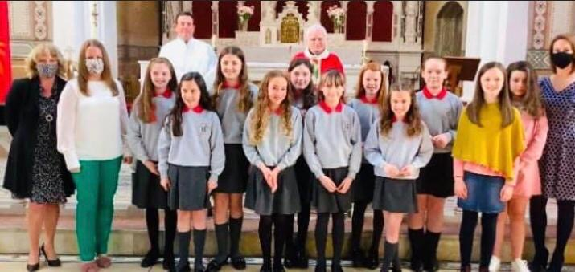
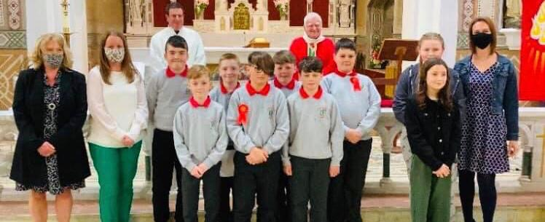
Confirmation: This year we had the celebration of Confirmation on 26th and 27th April. It was unusual circumstances but we want to congratulate them on how well they did on their Confirmation days. They made the school proud.
First Holy Communion- The Sacrament of First Holy Communion for the P.5 children, took place on Saturday 26th September and for the P4 children on Saturday 15th May’21 in St Joseph’s Chapel, Ballycruttle. We as a school community had a lovely day at both celebrations and we hope all our P4&5 families also enjoyed the day. The whole class made us proud. Congratulations to you all.
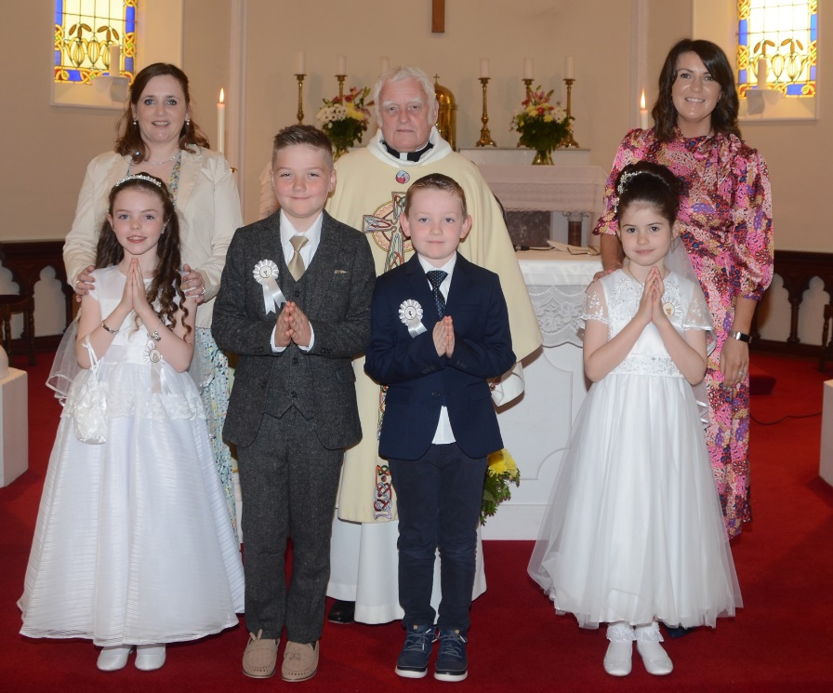

The P.4 and P.3 children also celebrated the Sacrament of Reconciliation on Tuesday 11th May. It certainly was a busy week for the P.4 children. They were all brilliant and made us proud.

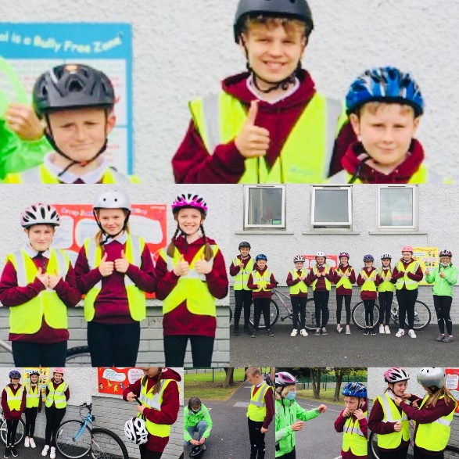
Cycling Proficiency-Thanks again to Sustrans who provided all the children in P6&7 with a bike safety check and spent a few days working with them to help them gain their cycling proficiency. Congratulations and thanks to all the children who took part.

Recent Events in Term 2 and 3
Saint Patrick’s Day fun: See the link below to the News article
https://www.stjosephspsballycruttle.com/news/green-day/?p=2&tags=,1084,

Easter Treat: https://www.stjosephspsballycruttle.com/news/we-had-a-big-surprise-when-bos-ice-cream-van-visited-today--a-great-start-to-the-easter-holidays/?p=2&tags=,1084,
Please see the above link to the news report on our Ice Cream treats and the following link for our Easter Egg fun news report. https://www.stjosephspsballycruttle.com/news/p1-3-had-a-super-easter-egg-hunt-this-year-with-beautiful-weather-and-lots-of-eggs/?p=2&tags=,1084,

https://www.stjosephspsballycruttle.com/news/easter-antics-in-p4-7-this-week/?p=2&tags=,1084,

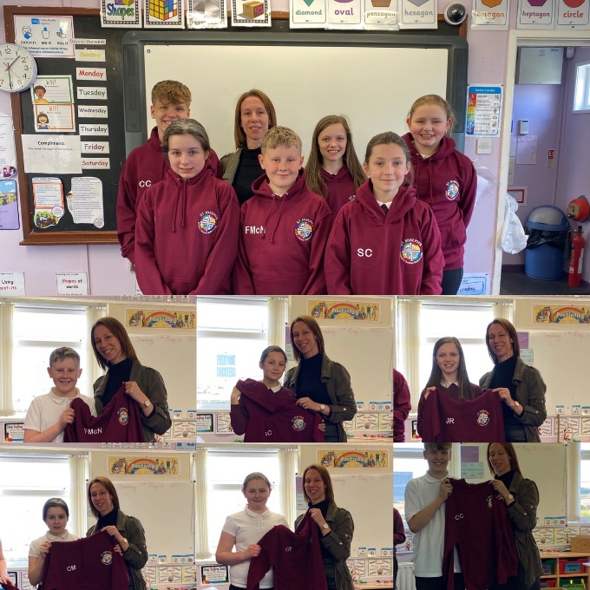
Jenna’s Dance Class: See Link to news article: https://www.stjosephspsballycruttle.com/news/p1-3-enjoy-jennas-dance-lesson/?p=2&tags=,1084,

Leavers Hoodies: P7 children presented with their leavers hoodies and started to wear their hoodies to school in Term 3. We wish them the best of luck as they move onto Post Primary School. They find out this weekend which school they have gained a place in. Good luck everyone.

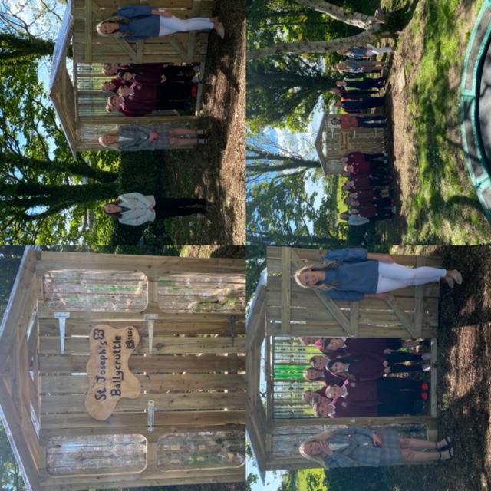
ECO Hut Delivered: The new ECO HUT which was a project between the students and staff at SERC College and our own ECO council and school community has been completed and delivered out to the school. The hut was made with the 2 litre drinks bottles the school community had collected over the last few years. The students and staff at SERC then put the hut together. It looks amazing.

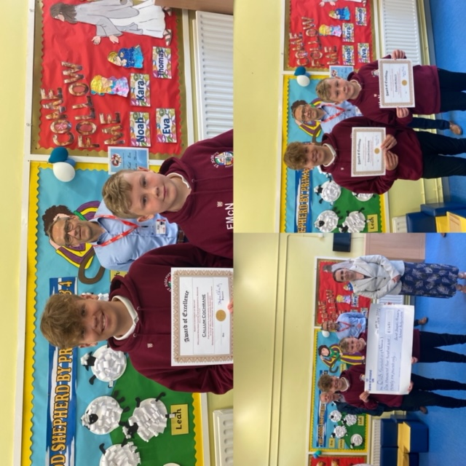
MS Research Collection: Fionn and Callum in P7 completed a sponsored walk for MS research at Queens University recently. They managed to raise £1491 and the cheque was presented to Stephen from Queens on Wednesday.

P4 Communion Party The children enjoyed a wee deserved party after celebrating their First Holy Communion.

Some Outdoor Play in P4&5
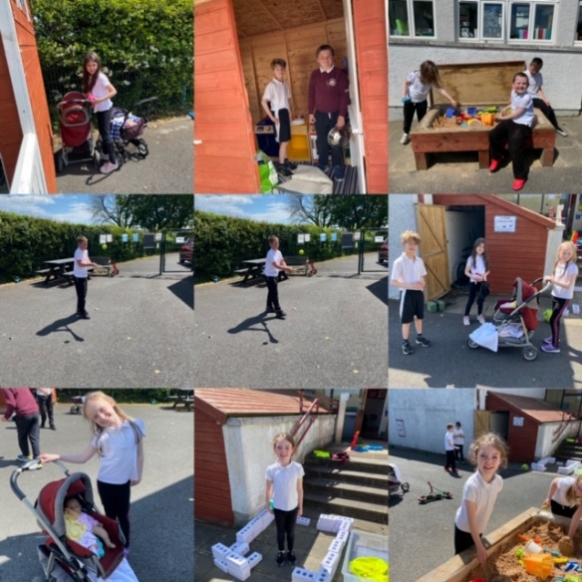

Up and coming events
School Trips- This year we haven’t been able to bring the children along to any trips which has been disappointing but thankfully we are able to offer two trips now within the next two weeks. The P6&7 group will be attending Greenhill YMCA next Thursday. They will be taking part in the same number of activities as previous year groups but will be unable to stay overnight due to covid restrictions in place. We hope they have a fantastic end of year trip. P.1-5 will be attending Exploris Aquarium on Tuesday 22nd June for their end of year trip. We hope to also arrange an end of year cinema trip in relation to funds left over in the PTA account. This will hopefully be finalised very soon as the cinema has only recently opened. The cinema is now fully booked with school groups so we can arrange this for September hopefully.

Revision and End of Year Tests: This week all classes are spending time revising key areas of Literacy and Maths as we will be completing out annual end of year tests next week. There will be no specific homework from now until the end of June. Please feel free to practise over key concepts at home over the next week.

Mathletics
We have been lucky this year to gain funds from the Education Authority to be able to provide a new online resource to our staff and children. Please remind your child/ren to use this invaluable resource at home and try to gain their 1000 points each week. This will be great for revision.

School Sports Day: We have scheduled in our annual Sports Day event on Monday 21st June. This may continue throughout Weds to Friday also depending on the weather. These sports events will take place during the school day. The children can wear their own Sports clothing this week apart from P1-5 on Tuesday who need to wear their uniform for their trip on Tuesday 22nd. Unfortunately we can’t have our normal Sports Day and BBQ due to restrictions.

24th June: P.7 leavers lunch in Currans and new P.1’s induction morning from 10am-12o’clock. Mrs Turley will contact the new P.1 parents to arrange this.

29th June- Awards ceremony in school

30th June Final Day Finishing at 11.30am

Provisional School Holiday list for 2021/22
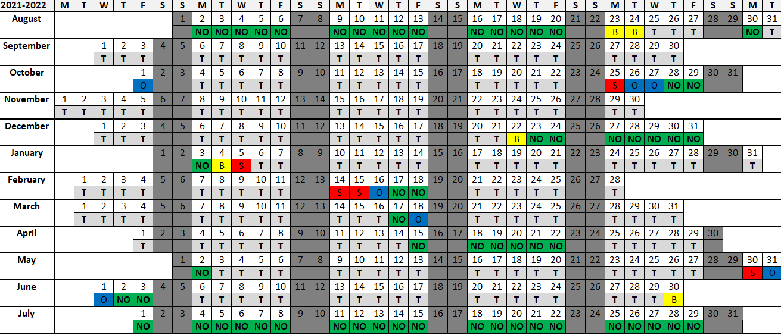
The children are in school on all the days labelled with a T and off school on the coloured days.
School begins for all pupils on Wednesday 25th August. There will be no hot meals from 25th-31st August so a packed lunch will be required.
This year we are using the new Seesaw App on the school Ipads as a communication tool and as a way to showcase your children’s work. Parents will be able to download the app at home and link up to their child’s class. You will also be able to view your child’s pieces of work and add a comment. The class teacher will be able to send announcements/messages to the class to inform you of things happening in the school. It will also be used by parents to send the class teacher images of their child’s homework. If you have any difficulty with accessing the app or taking pictures, please contact the school.
Remember also to visit the schools Facebook page Saint Joseph’s Primary School Ballycruttle @BallycruttlePrimarySchool and twitter account @SaintPrimary as well as the schools website https://www.stjosephspsballycruttle.com/
We would encourage all families to download the Schools NI App. You can then search for our school. Once installed you will receive notifications of school messages. The school will be using this method to communicate to our families. In emergencies the school will use the C2K Text Service. This service uses the emergency contact information that parents provided at the start of the year on the Data Collection Forms. Please ensure that these forms have been sent into the school so that we can update our records so that in the case of any emergencies we will have the correct contact details for each family group.
Let’s work in partnership to make sure your child has the best possible education in St. Joseph’s Primary School.

