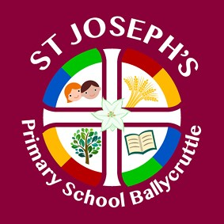
ST. JOSEPH’S PRIMARY SCHOOL
Principal: Mrs I Porter BEd Med CCET  E mail: iporter336@c2kni.net  Telephone: 02844 841546 |  | 45 BALLYCRUTTLE RD DOWNPATRICK  CO. DOWN  BT30 7EL
8/04/2020

Dear Parents/Guardians,

As you know Miss O’Hanlon has been teaching the P.1-3 children since September in place of Mrs Turley. Mrs Turley has informed the school of her intention to return to work on Monday 20th April.

Miss O’Hanlon has been a valued member of staff and will be sorely missed by all of the staff and pupils at the school. We hope that she will call in to see us all when we return to school.

On behalf of the Board of Governors, staff, pupils and parents we would like to take this opportunity to thank Miss O’Hanlon for all her hard work and dedication to the school and its pupils and would like to wish her best wishes for her future career.

Yours sincerely

Mrs Porter
Principal

