November /December News

School Photo's- Michael Shepherd the school photographer will be in school on Thursday 25th November. Let your class teacher know if you would like family photos taken.
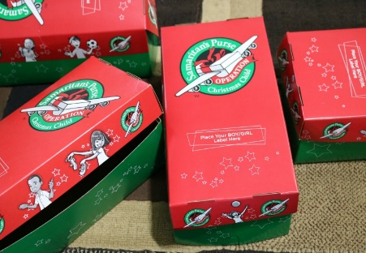
Samaritan's Purse Shoe Box Appeal: If you would like to take part in this year’s Samaritan's Purse Appeal, please see the following link to find out more. Shoe boxes should be in school on morning of 19th November as this is collection day.
https://www.samaritans-purse.org.uk/what-we-do/operation-christmas-child/how-to-pack-a-shoebox/
Samaritan's Purse Shoe Box Appeal

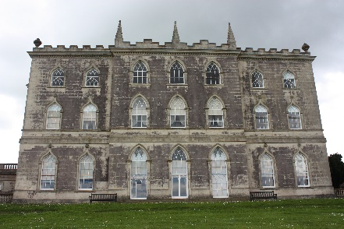
Yearly sponsored walk Sponsor Money Collection
in aid of school funds. So far a massive amount of £934 has been collected and we do have some more hopefully to come in. This is absolutely fantastic and we appreciate every penny of it. We will now be able to purchase the new projector which costs £450 and we will have plenty left for purchasing Non –Fiction Reading Books. Many thanks for your continued support of the school.

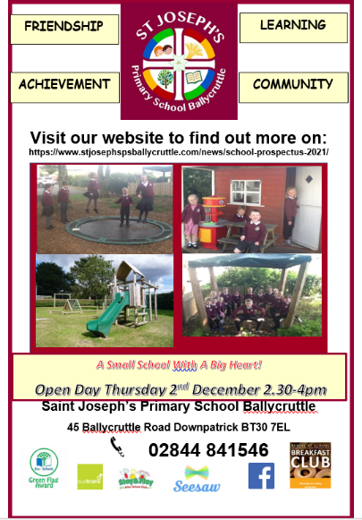
Cinema Trip (PTA funded)- Now re-arranged to Friday 26th November 10.30am screening time. The movie will last 1 hour 33 minutes and the children will each receive a drink, popcorn and sweet pack. A letter was sent home last week. Please return the permission slip as soon as possible. Collection time 12.30pm.

2nd December Open Day
Could all children be collected at 2pm on this day to facilitate the Open Day. Please let any family members, neighbours or friends know about our Open Day. Many thanks.
8Th December 2021 School closes at 2pm on this day in order to facilitate staff training. All children should be collected if possible by 2.05pm. Many thanks
Thursday 16th December- We hope to host our Christmas Play on this date in St Joseph's Church Hall. In order to do so a lot of extra precautions will need to take place such as restricted numbers and social distancing in the hall. The school will also have to complete a Risk Assessment. Please be patient while we work out all the finer details as we would love the children to be able to perform live for our families this year. The children in P1-3 will be performing Santa's Setbacks and the children in P4-7 will perform Stable Manners. The practising has begun!!
Please help your child/ren to practise their lines and the song lyrics over the next few weeks.
Christmas Raffle- Once the Shoebox Appeal boxes have been lifted this Friday we will be able to start taking donations for our Christmas Raffle. We would really appreciate your support again this year for our raffle and would like to ask all our families to send us in some items which could be used to make up our Christmas Hampers. Tickets for the raffle will be on sale in school throughout December. Items for the hampers/prizes can be sent in from next week. If you know or work in any local businesses who would like to support our raffle by donating a prize, that would also be greatly appreciated at this time.
School Christmas Dinner- There is currently no date finalised for our Christmas Dinner
21st December School finishes for the Christmas break half day at 11am. We wish all our families a Merry Christmas and a Happy New Year.
School starts again for Term 2 on Thursday 6th January 2022.

This year we are using the Seesaw App on the school Ipads as a communication tool and as a way to showcase your children’s work. Parents will be able to download the app at home and link up to their child’s class. You will also be able to view your child’s pieces of work and add a comment. The class teacher will be able to send announcements/messages to the class to inform you of things happening in the school. It will also be used by parents to send the class teacher images of their child’s homework. If you have any difficulty with accessing the app or taking pictures, please contact the school.
Remember also to visit the schools Facebook page Saint Joseph’s Primary School Ballycruttle @BallycruttlePrimarySchool and the schools website https://www.stjosephspsballycruttle.com/

We would encourage all families to download the Schools NI App. You can then search for our school. Once installed you will receive notifications of school messages. The school will be using this method to communicate to our families.
In emergencies the school will use the C2K Text Service. This service uses the emergency contact information that parents provided at the start of the year on the Data Collection Forms. Please ensure that these forms have been sent into the school so that we can update our records so that in the case of any emergencies we will have the correct contact details for each family group.
Let’s work in partnership to make sure your child has the best possible education in St. Joseph’s Primary School.

