PRIMARY
CHRISTMAS DINNER
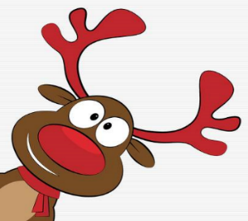
PRICE: £2.60
ROAST TURKEY, STUFFING, COCKTAIL SAUSAGES, PEAS,
baton CARROTS,
MASHED & oven baked ROAST POTATOES & turkey GRAVY
(SPECIAL DIETS WILL BE CATERED FOR)

Ice Cream & Fruit

ORANGE JUICE

