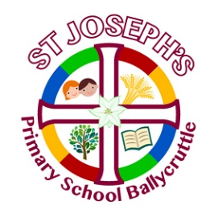
March Newsletter

Please remember to keep an eye on the New School Website and Download the Schools NI App from the App store. This Newsletter has been added to the website www.stjosephspsballycruttle.com

- Lent begins on Ash Wednesday which this year falls on March 2nd. During assembly and in school, we will be focussing on Lent. The children will be learning about how Lent is a Christian tradition which consists of nearly five weeks before Easter. Each class will discuss how they should be thoughtful, prayerful and give up things during lent in preparation for Easter celebrations.

Each class through their Grow in Love Scheme will talk about their Lenten choices and will discuss things to give up, things we should do such as help out more in the home and how we should say an extra prayer during lent. Have a look at the Mission Together website for lots of fun Lent and Easter activities that can be done at home as a family or at school: https://missiontogether.org.uk/calendar/lent/

This Photo by Unknown Author is licensed under CC BY-NC-ND
- Reminder: Compliments-We are a compliment’s giving school. Each Friday in the classrooms, one pupil is chosen to be given compliments from their class teacher and peers. This process is a way to increase their self confidence and self-esteem as well as teach everyone how we should treat each other by being ‘bucket fillers’ and not ‘bucket emptiers’.

- Confirmation 2022: -The Sacrament of Confirmation (P.7 children) took place on Tuesday 8th February at 4pm in St. Patrick’s Church, Saul. The children from St Patrick’s and St Joseph’s joined together to celebrate this special Sacrament together. The children from both schools made their schools and their families very proud. We hope you all enjoyed the celebrations.

- Have a look at the wonderful wall display the P7 children created when they were learning all about the gifts and the fruits of the Holy Spriit. We have such amazing and talented artists in our school.
The children also enjoyed a party in school:

Coming Events

Monday 28th February- Fire Safety Talk with NIFRS. Mr Carl Rodgers will visit the P4&5 children to talk to them about Fire Safety.

Tuesday 1st March- Pancake Tuesday- Pancake Day, or Shrove Tuesday, is the traditional feast day before the start of Lent on Ash Wednesday. Lent – the 40 days leading up to Easter – is traditionally a time of fasting and on Shrove Tuesday, Christians may go confession and be “shriven” (absolved from their sins). Shrove Tuesday always falls 47 days before Easter Sunday, so the date varies from year to year and falls between February 3 and March 9. Shrove Tuesday was traditionally the last opportunity to use up eggs and fats before embarking on the Lenten fast and pancakes are the perfect way of using up these ingredients.
This Pancake Tuesday we hope again to make Pancakes in school in order to celebrate the start of Lent on Ash Wednesday. Look out on our school website for some pictures of our Pancakes. If anyone has a dietry requirement, please contact the school before Pncake Tuesday.
2nd March- Ash Wednesday- Ash Wednesday is the first day in the season of Lent. Lent can be observed by all Christians, and it is a beautiful way to remember Jesus’ sacrifice for us and prepare us for the Easter season. During Lent, we remember the 40 days that Jesus spent in the desert being tempted by the devil. We do extra prayers, fasting, and almsgiving during this season of Lent. Ash Wednesday has many traditions for Catholic families and ways to observe this day, and also, anything you are doing for the length of Lent will start on this day. Have a look at the following website for more information on Ash Wednesday: see https://www.catholicicing.com/ash-wednesday-for-kids/
3rd March- World Book Day: https://www.worldbookday.com/
World Book Day
This year the children will be allowed to come to school wearing their pyjamas/onesies or something comfy so that they can enjoy a comfortable day of storytelling (£1 charge per pupil for school funds). The boys and girls have each received World Book Day tokens in February and will be able to use these tokens to purchase a book. On World Book Day in school, the children will be completing various activities in order to celebrate their love of reading.
Have a look at this Harry Potter Competition : https://www.worldbookday.com/harrypotter/
World Book Day was created by UNESCO on 23rd April 1995 as a worldwide celebration of books and reading. It is marked in over 100 countries around the globe.
The first World Book Day in the UK and Ireland took place in 1997 to encourage young people to discover the pleasure of reading.
This year is the 25th year there’s been a World Book Day, and on 3rd March 2022, children of all ages will come together to share the joy of reading for pleasure.
Spending just 10 minutes a day reading and sharing stories with children can make a crucial difference to their future success and it’s fun for all involved.
That’s why World Book Day continues to encourage children and young people to read for pleasure through its work with authors, illustrators, publishers, bookshops and libraries.
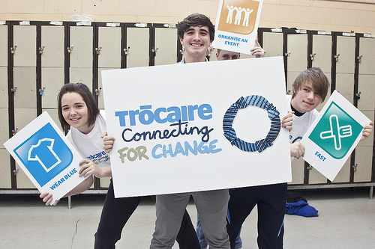
This Photo by Unknown Author is licensed under CC BY
Trocaire- It’s that time of year again when we begin to think about and raise money for Trocaire. We will have our annual raffle for Trocaire on Holy Thursday (14th April) morning. If anyone or any local business would like to donate Easter eggs, small gifts or food items for the raffle/hampers they would be greatly appreciated. Thank you for your generous donations in aid of Trocaire. Tickets will be on sale throughout Lent.

7th March Downpatrick Community Police Officers will visit KS2 pupils to give an important Internet Safety Talk to the children.

7th March- RISE NI will begin taking their weekly sessions with children in P1-3. There will be sessions once a week, every Monday until 11th April. Could all parents in P1-3 please return their RISE NI permission slips. Many thanks.

Wednesday 16th March- St Patrick’s Fun Day: Go Green For ST PATRICK. The boys and girls can dress up in GREEN to celebrate St. Patrick’s Day. £1 suggested donation for school funds.
17th & 18th March-No school due to St Patrick’s Day. Enjoy your celebrations.
21st March- Sustrans Big Walk and Wheel
Sustrans Big Walk and Wheel is the UK’s largest inter-school walking, wheeling, scooting and cycling challenge. It aims to inspire hundreds of thousands of pupils to get active on the school run. This year's challenge will take place from 21 March to 1 April 2022.
During the two-week challenge schools compete to record the greatest number of pupils walking, using a wheelchair, scooting and cycling to school, whilst learning about the benefits of active travel along the way. We will be recording our school’s active journeys this week. Remember you could also park at the Church Hall and active travel to school from there.
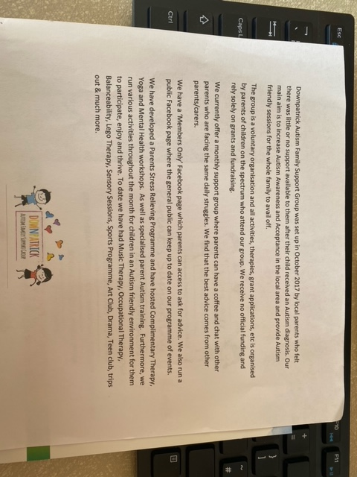
28th March- 3rd April- Autism Awareness Week- Downpatrick Autism Family Support Group have contacted the school for help. They are trying to raise awareness of the group in the local area and inform them of the support that is available to local families. They currently provide support to over 200 local families. They are currently working with Newry, Mourne and Down District Council to secure a plot of land where they can build an Autism Centre in Downpatrick. This would allow them to expand their services. They hope to secure funding but need to raise around £25,000 towards it and so are asking for our help. They would like the school to organise a non-uniform day during Autism Awareness Week (28th March- 3rd April) and so we have decided to support this local Charity and will hold a Non-Uniform day on Friday 1st April. We normally charge £1 each for non-uniform days but as this is for a local charity we would like you to chose what you would like to donate. Just out the donation in an envelop and we will pass the donations onto the Support Group. Many thanks for supporting this local charity.

Gaelic Football- Continues with Lorcan Harney every Wednesday until Easter. We thanks Saul GAC and Mr Mark McGrath for organising this coaching for both schools in our parish.

Actisports- Actisports will continue every Friday with the last session on 8th April. This is being paid for by the Wellbeing Fund which was provided to schools from the Education Authority.

Coronavirus- The Department of Education and Public Health have not changed any rules in school at the moment and so guidance remains the same as before Mid Term. If your child feels unwell and/or has any symptoms of Covid please isolate and take a PCR test. If your child is well, we would recommend Lateral Flow tests at least once a week but every day if there is a class or school outbreak.

Sacraments:-12th April Celebration of the Sacrament of Reconcilliation at 11am. More details to follow. Please ensure all Baptismal certificates are in school before this date. The Sacrament of First Holy Communion (P.4 children) will take place on Saturday 14th May at 11am in St Joseph’s Church, Ballycruttle.
We look forward to preparing the boys and girls for these special moments in their lives and celebrating with them and their families.

Easter Holidays:- 14th April Holy Thursday 11.30 am finish for Easter holidays. School begins again on Monday 25th April.

https://www.stjosephspsballycruttle.com/home/

This year we are using our new website as well as the new Seesaw App. Seesaw will be used on the school I pads as a communication tool and as a way to showcase your children’s work whilst at school. Parents will be able to download the app at home and link up to their child’s class. You will also be able to view your child’s pieces of work and add a comment. The class teacher will be able to send announcements/messages to the class to inform you of things happening in the school.
Remember also to visit the schools Facebook page Saint Joseph’s Primary School Ballycruttle @BallycruttlePrimarySchool. Let’s work in partnership to make sure your child has the best possible education in St. Joseph’s Primary School
Important Information for Parents/Guardians
Severe Weather Information /Priority Phone Numbers-
In the event that weather conditions prove to be severe it may be necessary to consider
closing the school to ensure the safety of the pupils and staff.
1. When severe weather is forecast the Principal will consider the information available. A decision will then be taken as to whether the school will close or remain open. The school will be closed only if the weather is exceptionally severe and to remain open would pose a significant risk to safety of pupils and staff (please be aware the majority of staff do live in rural locations.)
2. If the weather conditions become severe overnight and there is a risk that the school will be closed the next day: A decision to close the school will usually be made by the Principal by 7.30am at the latest on the day in question. For sustained periods of bad weather, a decision will be made at the earliest possible time the evening before. The Principal will contact the local media, the Chair of the Board of Governors and the Department of Education to inform them of the decision to close.
Parents and Staff will receive a text* using the school’s C2k text service. The School Facebook account and Seesaw may also be used to publicise a School Closure!
Local media will be informed of the school’s decision to close. The BBC will publish a list of schools that are closed on the BBC’s Digital Text Service and, in the event of a significant number of schools deciding to close on the BBCNI news website at: http://www.bbc.co.uk/ninews
An Emergency School Closure Notice will also be posted on the NI Direct Website.
The link to the NI Direct page is http://www.nidirect.gov.uk/list-of-school-closures
3. If the weather turns severe after the beginning of the school day and it is decided that the school must close early: Parents /Guardians will receive a text* using the School’s C2k text service.
4. If the school is opened as normal but there are severe weather conditions forecast for the local area. Parents must decide for themselves whether it is safe for their child to travel to school. If the child is kept at home, then their absence should be notified to the class teacher on their return in the normal way. If severe weather closes in when a child is at school and a parent wishes their child to leave for home early, the parent should contact the school for arrangements to be made. Depending on the circumstances the school may advise that it would be safer for the child to remain in school for a time before leaving for home.
All such arrangements must be made by the parent through the school secretary/Principal to ensure that relevant staff are aware of pupils’ whereabouts.
*C2K Text Service- The information used to contact parents by C2K Text is the Priority 1 Numbers parents have provided in their Data Collection Sheet at the beginning of the school year. This is the number parents/guardians have indicated as being the number to be used in an emergency situation such as school closures as mentioned above. If you need to change this Priority/Emergency Number which will be used for the C2K Text Service and in the event of an emergency, please let the school know as soon as possible so that the school SIMS Records can be updated appropriately. This emergency number is normally a mobile number.

