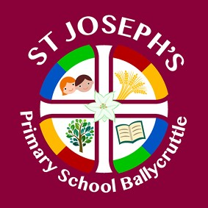
ACHIEVEMENT

FRIENDSHIP
LEARNING
COMMUNITY
Visit our website to find out more on:
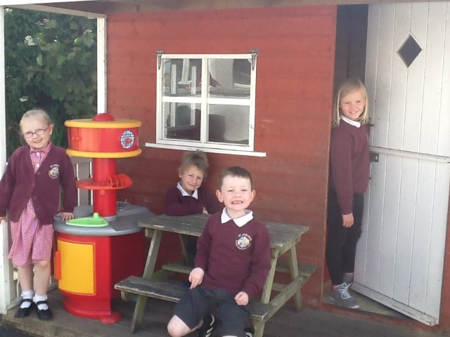
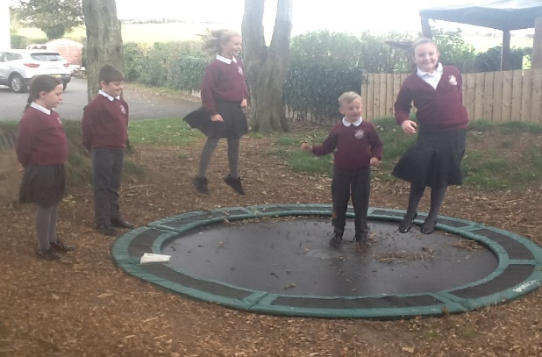
https://www.stjosephspsballycruttle.com/news/school-prospectus-2021/
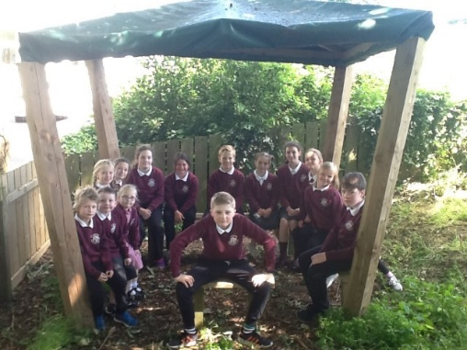
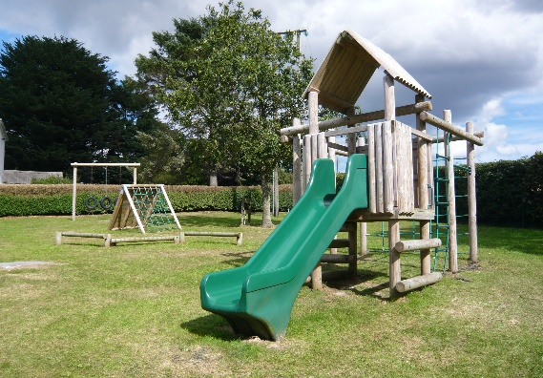

A Small School With A Big Heart!
Open Day Thursday 2nd December 2.30-4pm

Saint Joseph’s Primary School Ballycruttle
45 Ballycruttle Road Downpatrick BT30 7EL
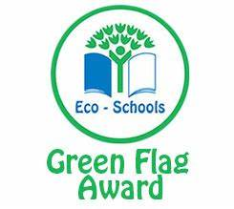
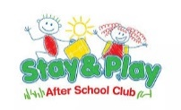
02844 841546

ACHIEVEMENT
FRIENDSHIP
LEARNING
COMMUNITY
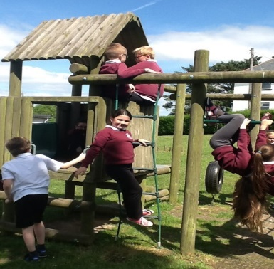
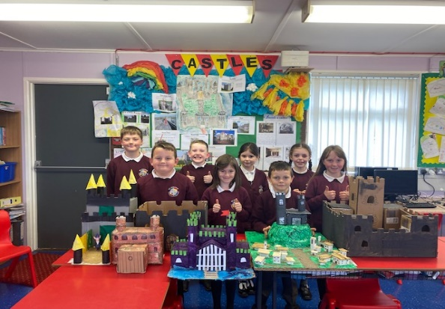

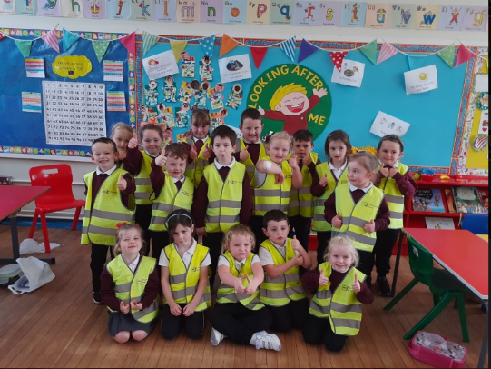
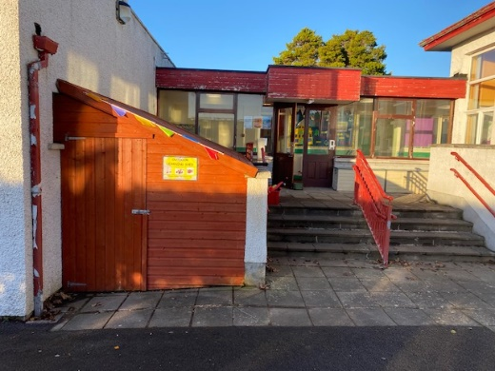

Feeder school to new Proposed Co-Educational Voluntary Grammar School due to open in Downpatrick.
Have a look at our new school website and get a feel for our school and meet our staff or feel free to contact the Principal Mrs Imelda Porter, to talk about life in St Joseph’s.
Here in St Joseph’s we seek to nurture the whole child by providing a broad, balanced, challenging and stimulating learning experience within a safe, caring, well-resourced and happy learning environment. As a catholic school, our core aim is to establish an environment where children, staff and parents feel welcome. Saint Joseph’s have a committed and caring staff that work closely in partnership with the parents, parish and governors to deliver the highest quality of standards of pastoral, academic and interpersonal education.
We have extensive school grounds which includes four different outdoor learning areas. We have recently gained our ECO Schools Green Flag and have joined the Sustrans N.I. programme.

