St Joseph’s Primary School Prospectus

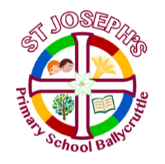

‘A small school with a big heart’

'We want our school to be a place for everyone. To do
some work and have some fun! Where people feel like
they belong. We ask God’s Holy Spirit to be active here.
To make an atmosphere of joy, peace and love.'

Contents
Contents 2
Principal’s Welcome 4
Mission Statement 5
Background 6
Our School Accommodation and Resources 7
Development Proposal De La Salle, St Mary’s and St. Patrick’s Grammar 8
Staff 9
Board of Governors 10
Our Curriculum 10
Teaching and Learning 11
Homework 13
Good Practice Guidelines for Homework 13
Religion 14
Supporting Charities 14
Sports and Extra Curricular Activities 15
Admissions 16
School Uniform 17
Times, Dates and Holidays 18
School Day Schedule 18
Break and Lunch 19
Discipline 19
Pastoral Care 20
Child Protection 20
Special Educational Needs 21
Parents 21
Parents Support Group 22
Photo Gallery 23

Principal’s Welcome

Dear Parent/ Guardian / Carer

Thank you for taking the time to consider Saint Joseph’s
Primary School for your child’s education. I hope you find this prospectus helpful and it provides you with a brief flavour of what life is like in Saint Joseph’s Primary School.

As a Catholic school, our core aim is to establish an
environment where children, staff and parents feel welcome. Saint Joseph’s has a committed and caring staff that work closely in partnership with the parents, parish and governors to deliver the highest quality of standards of pastoral, academic and interpersonal education. We seek to nurture the whole child by trying to provide a broad, balanced, challenging, stimulating learning within a safe, caring, well-resourced and happy learning environment.

Of course no booklet can convey the real atmosphere of a
school and it is only through visiting or spending time
here at Saint Joseph’s that you will discover the wonderful ethos present and the positive relationships
between children and adults. All parents and prospective
parents are most welcome to visit the school and we look
forward to meeting you and welcoming your child into the community of Saint Joseph’s.

Mrs I Porter
Principal

Mission Statement

We at Saint Joseph's aim to provide a happy and caring atmosphere for the child where they feel secure and fulfill their potential.

We will acknowledge their achievements and individual strengths and differences.

We aim to promote self-esteem and provide a solid foundation to help them to progress to adulthood.

We will:

- Encourage each child to be confident, independent and
responsible learners through a curriculum which suits the needs of each individual;

- Promote the development of lively and enquiring minds to acquire the skills towards self-learning;

- Develop respect for others in terms of religion, race and
personal circumstances; and

- Encourage the children to become active and interested
members of the wider community.

‘A small school with a big heart’

'We want our school to be a place for everyone. To do
some work and have some fun! Where people feel like
they belong. We ask God’s Holy Spirit to be active here.
To make an atmosphere of joy, peace and love.'

Background

Saint Joseph’s Primary School was first established in 1864, although we are now in this existing building since 1948. Our school has strong links with the parish, serving the people of Ballycruttle and surrounding parishes. We have an excellent reputation for catering for the individual needs of each child. We pride ourselves on being a warm, friendly and welcoming school for all. Children of all backgrounds and faiths are welcome at Saint Joseph’s.

Our School Accommodation and Resources

The school building is a well maintained and stimulating learning environment. We have 3 bright, spacious and comfortable classrooms. All classrooms have interactive whiteboards, a wide range of learning resources for all curriculum areas and a well resourced library.
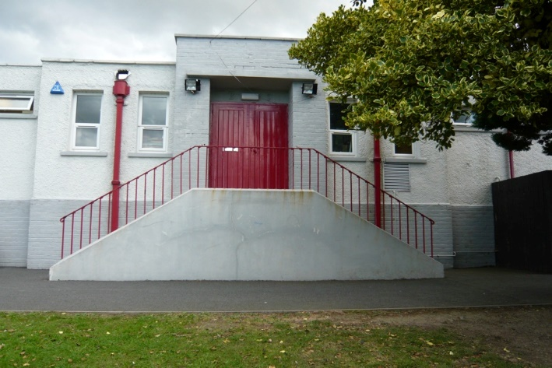

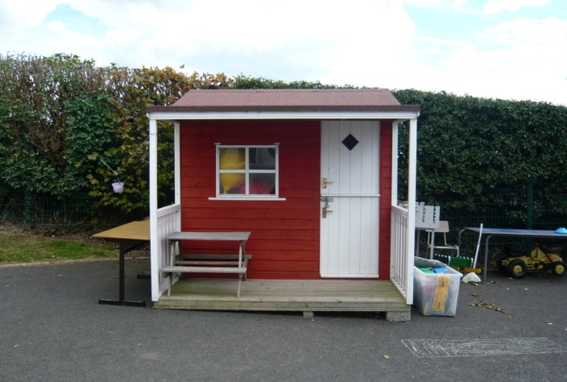

Although we are only 5-10 minutes drive (4 miles) from Downpatrick we are situated in the heart of the countryside. We have four outdoor learning/play areas for the children to learn or play which consist of grassy areas, netball court, adventure park, outdoor structured play area and a quiet garden.
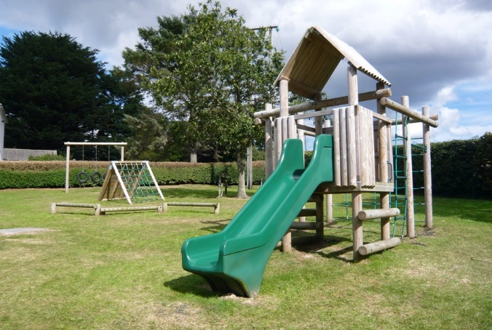
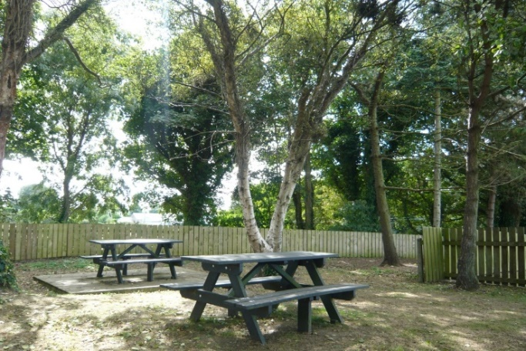

Development Proposal De La Salle, St Mary’s and St. Patrick’s Grammar

The proposal is to create a new co-educational 11-19 voluntary grammar school for 1,600 pupils which will be established from 1st September 2021. The new school will utilize the three school buildings until a new one site solution can be created. The school will have an admission number of 250 pupils with up to 40% being admitted through academic selection. They propose to remove academic selection for those for whom the school is the nearest Catholic post-primary school (11 local feeder primary schools of which we are one of those named) and to retain academic selection for up to 40% of those for whom the school is not the nearest Catholic post-primary school (24 primary schools).

We are in the fortunate position to be one of the 11 feeder primary schools in which academic selection will not be required and the children from our school will automatically gain a place.

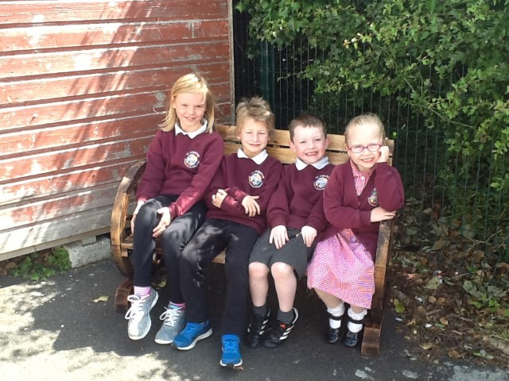

Staff

Teaching Staff Learning Support Teacher
Mrs H Turley Mrs A O’Hare
Mrs L Cochrane Principal Release Teacher
Mrs I Porter Mrs C Dornan

Non- Teaching Staff
Classroom Assistants Secretary: Mrs Sheree Mageean
Mrs I Fitzsimons School Catering Assistant: Mrs AM Brannigan
Mrs F Carson School Building Supervisor: Mrs AM Brannigan

Board of Governors
The Board of Governors consisting of representatives of the Catholic Church, Department of Education, Education Authority (South Eastern Region), parents and staff have responsibility for the appointments of staff and running the school.

In St Joseph’s the Board of Governors play an active role in all aspects of school life. They fully support the teaching and learning taking place in the school by:
- Monitoring and reviewing school policies on learning;
- Supporting the staff of the school;
- Self-evaluating their own governance; and
- Monitoring and evaluating school development planning and action planning.
Fr Alexander.............................. Trustee Representatives
Mrs Rogan....................................Trustee Representatives
Mr J Breen………........................Trustee Representatives
Mrs Kearney................................ Trustee Representatives
Mr Morgan....................................EA Representative
Mr McNulty..................................EA Representative
Mrs Mullan…..............................DENI Representative
Mrs Sharvin..................................Parent Representative
Mrs Cochrane...............................Teacher Representative
Parents can address the Board of Governors via the Parent representative.

Our Curriculum

The curriculum is the sum of all the learning experiences present for each child, those planned by the teacher and those that emanate from our school ethos and environment.

Our curriculum takes into account the uniqueness of each child and his/her individual needs. We adapt a child centred approach to the curriculum. Our balanced curriculum is in line with the Education (NI) Order 2010 and involves the learning areas of:

- Language and Literacy
- Mathematics and numeracy
- The Arts (including Art & Design, Drama and Music)
- The World Around Us (including Geography, History and Science)
- Religious Education
- Personal Development and Mutual Understanding
- Physical Education
- ICT

Across the curriculum we have an emphasis on the development of skills and capabilities for lifelong learning and for operating effectively in society.

These whole curriculum skills and capabilities include thinking skills and personal capabilities and cross-curricular skills.

Teaching and Learning

At Saint Joseph’s we have 3 full time teachers and one Principal Release teacher. We also have a part time learning support teacher. We plan our lessons in line with the revised Education (NI) Order 2010. However, in our school teaching is not just classroom based but all learning that emanates from our school ethos and environment.

Teachers are committed and enthusiastic and they enjoy a positive relationship with the children, parents and all school based staff.

As a schooling community we strive to raise standards and set realistically high expectations which both challenges and inspires pupils.

Teachers use adaptable flexible teaching strategies that respond to the range of abilities within the classroom.

Learning activities are broad and balanced and incorporates the learning areas of communication, using mathematics, the world around us, personnel development and mutual understanding, physical education and we use ICT throughout.

Learning activities develop the pupil’s cross curricular skills, thinking skills and personal capabilities and promote risk taking and independence.

Homework

Homework is defined as the time students spend outside the classroom in assigned learning activities. At Saint Joseph’s Primary School, we believe that homework is an important part of children’s learning. We use homework as a way of keeping parents up to date on what their child is learning in school and to reinforce in school learning. We have made our homework guidelines so that they reflect government policy.

Good Practice Guidelines for Homework
Homework should be:
- completed regularly and fully.
- neatly presented.
- supported and encouraged by parents.
- Signed by parents/carers.
- Set for children’s individual ability
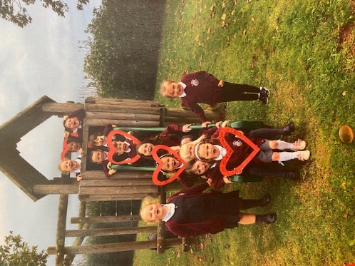
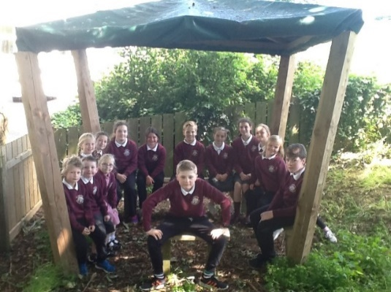

Religion
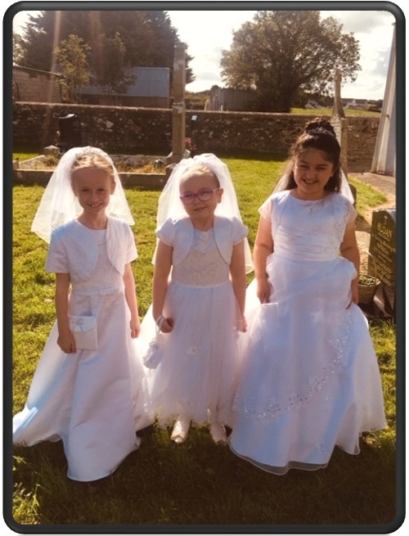
As we are a Catholic maintained school we have a role in the religious life of the child. The RE programme is based on the Alive-O series as well as the new Grow in Love Programme. We prepare children for the sacraments of First Confession(P3), First Holy communion (P4) and Confirmation(P7). We work closely with our local Priest.
Children from all denominations are welcome at our school.

Supporting Charities
We feel it is important to teach children about the need to look beyond our own need and help others who are not as fortunate as we are. During the academic year we try to raise money for:

- Action M S
- Trocaire
- Samaritans Purse (shoe box appeal)
- Macmillan Cancer-Coffee Morning
- Other Cancer charities such as NI children’s cancer fund or Action Cancer.

Sports and Extra Curricular Activities
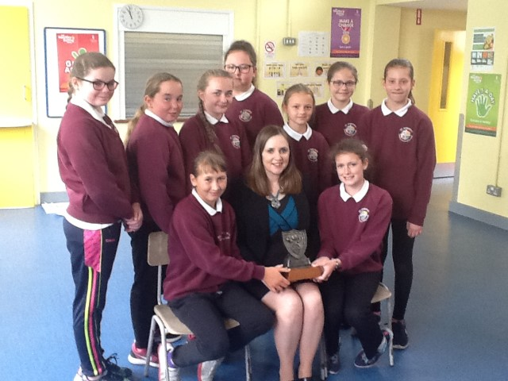
The Board of Governors are aware of the importance of visits and other enrichment activities in the development of our children. These form a major part of Saint Joseph’s education. Children take part in a wide variety of visits throughout their school life.
Winners of the Lecale Cup Gaelic Tournament June ‘18

We join with external agencies to provide a wide range of sporting and musical activities. We believe that every child should leave primary school with a sport they take part in or with an instrument they should try. Saint Joseph’s offers Gaelic Football, Soccer, Netball, basketball, gymnastics, swimming, Music tuition and dance throughout the year. We have close links with local sporting organisations and can introduce parents and children to them. We also offer after school’s clubs such as Stay and Play and Gaelic Football Coaching to add to the breadth of experiences on offer.
After School’s clubs run throughout the week with a variety activities being offered throughout the year. We also offer a Breakfast club from 8.15am each day.
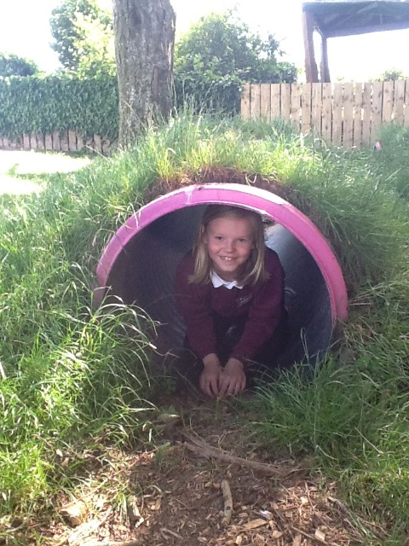
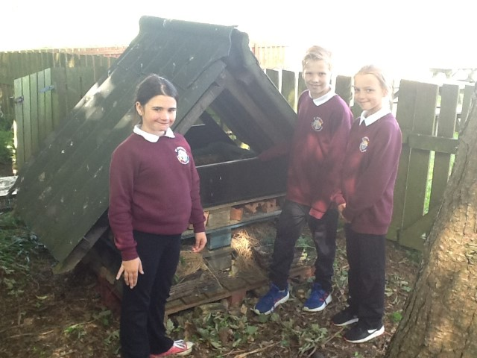

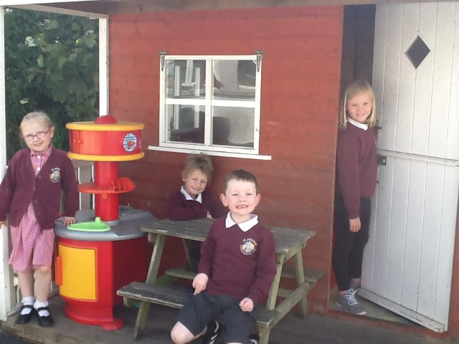
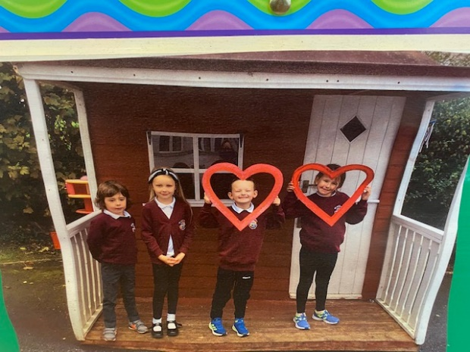

Admissions
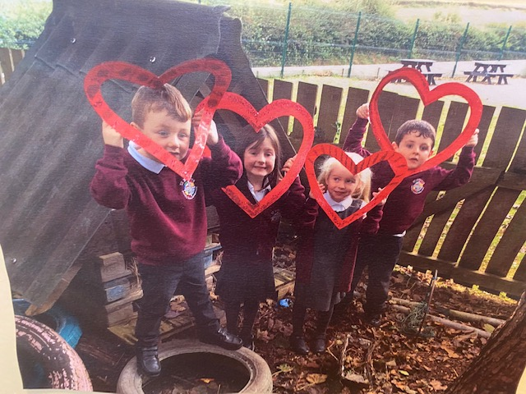
In selecting children for admission to the school the Board of Governors will apply the criteria as set out in the Education Board Handbook.

We hold an open afternoon for new families to come to see our school in December of every year. However, anyone is welcome to phone the school and we will certainly arrange an individual visit.

School Uniform
It is important that children come to school neat and tidy. Our uniform reflects the individuality of Saint Joseph’s and offers a reasonably priced form of common dress.
Compulsory Uniform- We as a school are very lucky to have such a wonderful uniform which has been compulsory since Sept’18. See the images and information below with relation to the uniform. If purchases need to be made, Pricewise in Downpatrick provides the school uniform.

If you would like to investigate whether or not your child may be eligible for a school uniform grant, please see the following link. https://www.nidirect.gov.uk/articles/school-uniform-and-uniform-grants
Or see the following link to apply.
http://www.eani.org.uk/i-want-to/fsm/howtoapply/

Day to day uniform: - Burgundy school jumper or cardigan with the new school crest, Grey trousers or grey skirt/pinafore with a white polo shirt with white or grey socks or grey tights/burgundy socks/tights.

Summer Season adjustments allowed-adjust grey trousers to grey school shorts only, adjust grey pinafore/skirt to red checked dress with white, grey or burgundy socks.

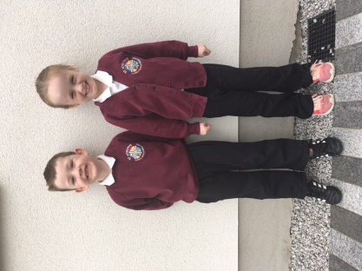
P.E. Uniform Adjustments (Wednesday/Friday or when requested by the school)- School trousers/skirt/pinafore can be swopped for plain black tracksuit bottoms only.
We look forward to seeing everyone in their smart new uniforms in September.

Times, Dates and Holidays

A list of school holidays is available at the start of the school year.

School Day Schedule

Time | Schedule
8-15-8.50/9am | Breakfast Club (£1 per pupil/day or £4 per week)
8.50/9am | P.6&7 school starts at 8.50am P.1-5 school starts at 9am.  Classroom Supervision-register taken, dinner, afterschools, swimming and/or other money collected at this time by the teacher/assistant.*(see note)
9.05am | Class begins  (9.05-9.15 Monday & Friday Assembly)
10.45am | Break Time (Teachers/pupils)
11am | End of Break time
12.15pm | Lunch time (Pupils)
12.45pm | Outside Play
1.15pm | End of Lunch
2pm | P1-3 School Ends
3pm | P4-7 School Ends
Friday | P1-7 School Ends at 2pm

*School office is only open for the collection of money between 8.45 am and 10.45 am, Monday-Friday. Money is to be handed into the class teacher at registration. Money for the week (dinner/swimming/afterschool/breakfast club etc.) should be paid on a Monday if possible. Any dinners etc. missed due to absences will be carried over to the following week.

Due to strict guidelines from the Education Authority we can only accept money when the school office is open. Thank you for your co-operation.

*School timetable is slightly different due to current Covid-19 guidelines

Break and Lunch
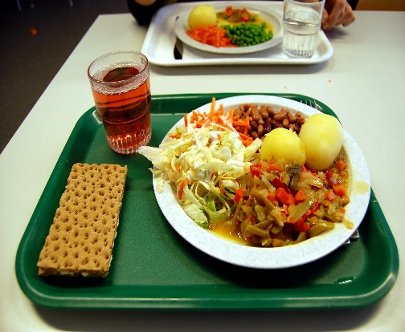
We offer well balanced school meals for the children. The dinners are cooked in the main canteen for this area St Nicholas’ Primary School (Ardglass). The children enjoy the dinners as there is a good variety of food on offer over the course of a week. School meals cost £2.60 per day or children may be eligible for free meals. If you wish to enquire if your child may be entitled to free school meals, please follow the link below:
This Photo by Unknown Author is licensed under CC BY-SA

https://www.nidirect.gov.uk/articles/nutrition-and-school-lunches

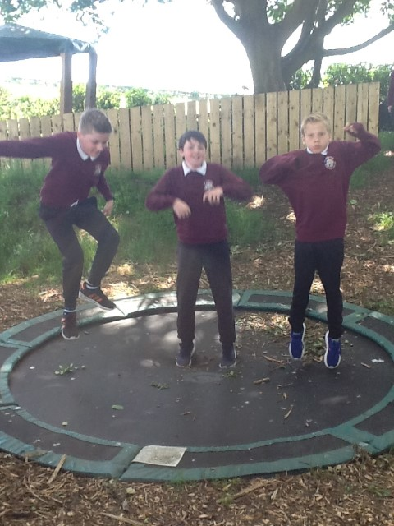
The school promotes healthy eating and pupils are encouraged to have a healthy alternative such as fruit and yoghurts for their break time snack and a labelled bottle of water or sugar free juice to drink.

Discipline
The school focuses on the development of a positive and caring climate which is based on respect. We are quiet, understanding but firm in the way we encourage high standards of behaviour. We promote positive behaviour through simple reward and merit schemes. We use fair sanctions which the children’s council helped to decide.

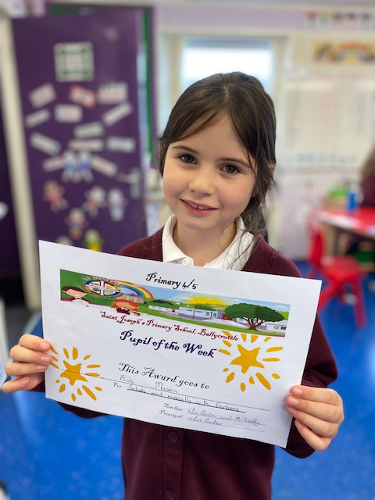
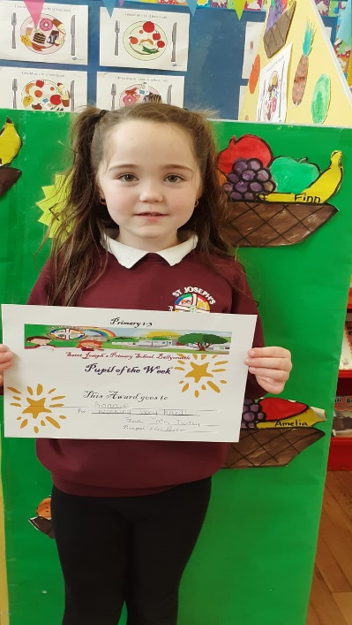

Pastoral Care
Pastoral care permeates all aspect of school life. It reflects the values, attitudes, beliefs and practices of our Catholic faith. In Saint Joseph’s Ballycruttle we try to create caring, happy children who have gained skills and positive attitudes necessary for adult life. We aim to nurture confidence, tolerance, understanding and a good attitude to life long learning
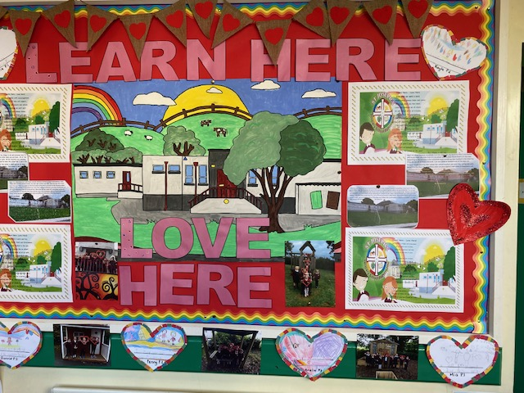

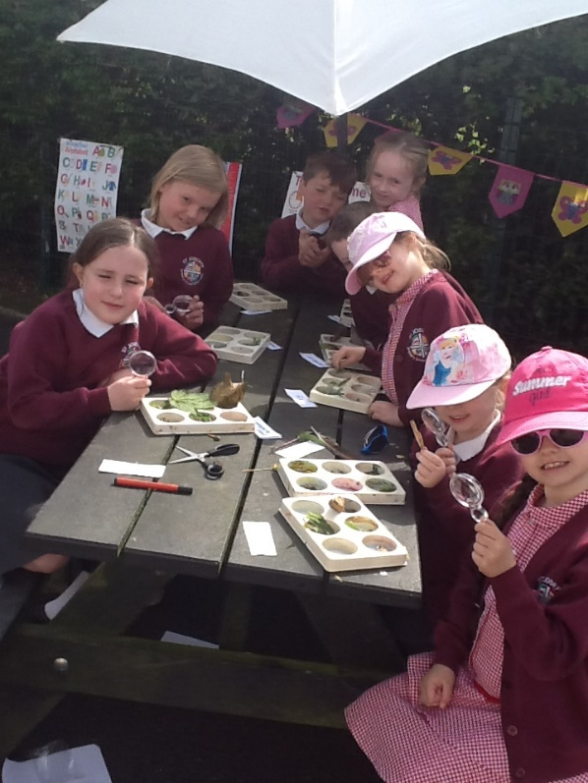
Child Protection
Our staff are trained in child protection ensuring the welfare of all children in our care. The designated child protection teacher is Mrs Cochrane and the Deputy Designated Teacher is Mrs Turley. The children are made aware of these roles and know who they can approach in times of need.

Special Educational Needs
The early identification of children with Special Educational needs is a priority at Saint Joseph’s. The Special Needs Co-ordinator liaises with class teachers to identify specific needs and draw up individual education plans for these children. The class teacher will cater for the identified needs of each child. Parents are kept informed of their child’s progress during regular consultations. The school also works closely with outside agencies in order to meet the needs of all children. We are also lucky to have a Learning Support Teacher, two days per week who can offer one to one or group support.
This Photo by Unknown Author is licensed under CC BY-NC-SA

Parents
Children’s education is an on-going partnership between home and school. Parents are the children’s first educators and teachers. Home and school share in the child’s education. Parents are always welcome at Saint Joseph’s and the staff are committed to fostering excellent home/school links.
To keep our parents well informed they are invited to the school in the first term for a curricular meeting which gives a general outline of the work to be covered and class routines. Also in the first term individual parent interviews are held to discuss and review your child’s progress.

Parents who have any concerns or worries about their child can arrange further appointments with the class teacher or Principal.

Parents also have a responsibility to the school. We would like parents to;
- Ensure their child has the best punctuality and attendance possible;
- Ensure that their child is well equipped for school;
- Do their best to keep the child healthy and fit for school;
- Inform school if there are matters outside of school that are likely to affect performance or behaviour in school; and
- Promote a positive attitude towards school and learning in general.
- Read and Follow all school policies

Parents Support Group
We have had a very active parents group in the past who have worked throughout the years raising monies to fund anything from outdoor play equipment to trips and excursions. At the moment we don’t have a Parent Support Group but as a small school we would ask all of our parents to support us with any fundraising opportunities. Feel free to suggest fundraising ideas to the staff or help out with the school’s fundraising opportunities as we appreciate the help and support we receive from our school community.

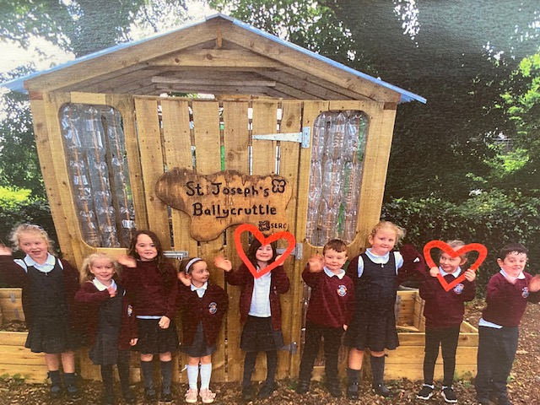
Photo Gallery

