School Uniform and school day schedule
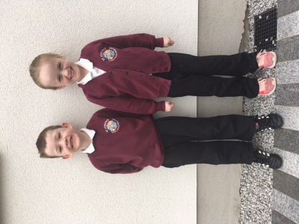
Compulsory Uniform- We as a school are very lucky to have such a wonderful uniform which was designed by the school community. See the images and information below with relation to the uniform. If purchases need to be made during the holidays, Pricewise in 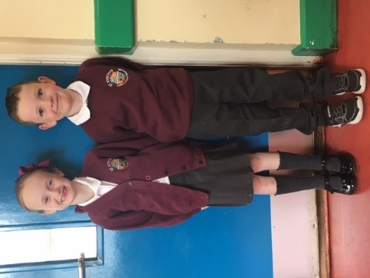Downpatrick provides the school uniform. If you would like to investigate whether or not your child may be eligible for a school uniform grant, please see the following link. https://www.nidirect.gov.uk/articles/school-uniform-and-uniform-grants
P.E. Uniform
Or see the following link to apply.
http://www.eani.org.uk/i-want-to/fsm/howtoapply/
Day to day uniform: - Burgundy school jumper or cardigan with the new school crest, Grey trousers or grey skirt/pinafore with a white polo shirt with white or grey socks or grey tights/burgundy socks/tights. Black shoes.
Summer Season adjustments allowed-adjust grey trousers to grey school shorts only, adjust grey pinafore/skirt to red checked dress with white, grey or burgundy socks.
P.E. Uniform Adjustments (Wednesday/Friday or when requested by the school)- School trousers/skirt/pinafore can be swopped for plain black tracksuit bottoms only. Footwear-Trainers.
We look forward to seeing everyone in their smart new uniforms in September.

School Day Schedule

Time | Schedule
8-10-8.45 | Breakfast Club (£1 per pupil/day or £4 per week)  Please contact Mrs Porter by email to book into breakfast club
8.45-9am | Classroom Supervision-register taken, dinner, afterschool’s, swimming and/or other money collected at this time by the teacher/assistant.*(see note)
9.05am | Class begins  (9.05-9.15 Monday & Friday Assembly)
10.30am | Classroom Assistant Break
10.45am | Break Time (Teachers/pupils)
11am | End of Break time
12.15pm | Classroom Assistant Lunch
12.25pm | Lunch time (Pupils)
12.45pm | Outside Play (Classroom Assistant lunch ends)
1.15pm | End of Lunch
2pm | P1-3 School Ends  *P1 September finish at 12o’clock
3pm | P4-7 School Ends
Friday 2pm | P1-7 School Ends

*School office is only open for the collection of money between 8.45am and 10.45am, Monday-Friday. Money is to be handed into the class teacher at registration). Money for the week (dinner/swimming/afterschool/breakfast club etc.) should be paid on a Monday if possible. Any dinners etc. missed due to absences will be carried over to the following week. Due to strict guidelines from the Education Authority we can only accept money when the school office is open. Thank you for your co-operation.

- Afterschool Clubs to be organised for Sept’21

