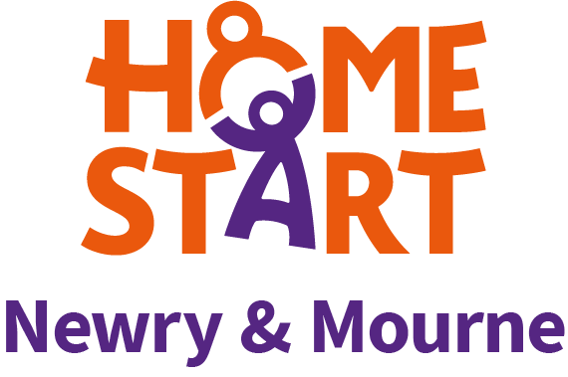
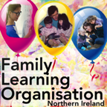 in association with

EMAIL: flo.nireland@gmail.com FACEBOOK: @FLO.NIreland TWITTER: @IrelandFlo

Enabling teachers, parents and children to continue learning during the Covid-19 pandemic

THE FAMILY LEARNING ORGANISATION – FLO has been working with Teachers, Parents/Carers and Young People for over 10 years. They are continuing this work by offering the second round of webinars for parents, teachers and anyone working with children and young people.

We are delighted to announce our new webinars for Spring:

NEW WEBINARS:
- TUESDAY 16th March at 8.00pm: Liz:
“Home working: persistence, motivation, resilience and growth mindset.” (Helpful homework hints.)

- TUESDAY 23rd March at 8.00pm: Kate:
“Reading comprehension: using mediated learning approaches in order to improve reading comprehension.”
(Improving the thinking skills useful when we are reading for meaning.)

- TUESDAY 30th March at 8.00pm: Colette:
“Using the language of Maths with confidence.”
(“Ideas to help learners think Mathematically.)

FLO SESSIONS WILL LAST 90 MINUTES WITH AMPLE TIME FOR QUESTIONS

Each SCHOOL which registers will have access to all 3 webinars
for ALL STAFF and PARENTS for a one-off fee of £100

Payment is by PAYPAL, Credit Card, Bank Transfer,
Cheque OR Direct Debit:

email flo.nireland@gmail.com and we will send the necessary details and an invoice.

Those who subscribe will be sent the ZOOM link the Thursday before each event.

We would be delighted if you could spread the word about these webinars by sharing with others you feel could benefit.

(Registration is now open via email flo.nireland@gmail.com)

FLO TEAM

With a career in nursing, midwifery, mental health, health visiting and teaching, Liz Jones has drawn on her wealth of knowledge, experience and previous research to promote child-centred parenting. Through the Family Learning Organisation, Liz will focus on the family and will explore techniques and strategies that work best for families in these challenging times.

Kate O’Hanlon, a member of the Family Learning Organization for over ten years, is a teacher, psychologist, researcher and accredited trainer of Instrumental Enrichment, a programme dedicated to developing the thinking skills of young people, particularly those who find learning more challenging. Her areas of interest are language and literacy, young people who may be dyslexic and encouraging a focus on thinking skills

As a teacher, adviser and tutor, Colette Delargy has devoted her working life to finding ways of making Maths more accessible to people. She particularly enjoys helping children who think they can’t do Maths overcome their difficulties and succeed with a newfound confidence. As a member of the Family Learning Organisation, Colette will show parents easy, fun activities they can do at home to help their children become better at Maths.

We look forward to hearing from you.

Colette Delargy
Liz Jones
Kate O’Hanlon.

March 2021.

