St Joseph’s Primary School

Covid-19

School Policy and guidelines

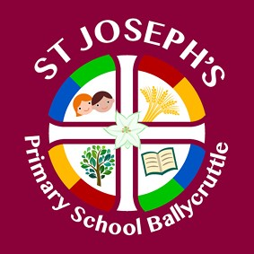

Date: | August 2020 | Next Review Date:

Contents
Contents
Contents 1
1. Background 4
2. Rationale for the Plan 4
2a) Three Strands 4
Prevention: 4
Response to any infection 5
Operational plan for continuation or provision 5
2b) Safety and well-being for pupils 5
2c) Safety and well-being of staff 5
2d) Overall safety and well-being 6
3. Bubbles 6
4. Protective Measures & Arrangements 6
4a) Expectations of Parents and Staff 6
4b) General Hygiene 7
4c) Cleaning 8
4d) Classrooms 8
4e) Distancing and adult to child contact 9
4f) Specific Year Group guidance 9
4g) Outdoor Spaces 9
Toilet at break and lunch 10
5) Organisation of the Day 10
5a) Start and End of Day 10
5b) Arrival procedures: 10
5c) Pick up procedures 11
5d) Late Pick up: 11
6) Bringing items from home/school 11
7) School Uniforms 11
8) Moving Around the School 11
Children’s general movement around school 12
9) Break and Lunch 12
Lunchtime: arrangements 12
10) Playground Equipment 13
11) Wrap around care and after school clubs 13
7a) Breakfast and After school clubs 13
12)Office area guidance 13
13) Welfare 13
14) Evacuation procedures 13
15. Pupil Attendance 13
Which children may not attend school? 14
16 Blended learning 14
17 Curriculum 14
17 a) Feedback to Pupils 14
73 b) Physical activity 14
17 c) Use of External curriculum providers/Extra curricular providers 15
18. Dealing with suspected or confirmed cases of Coronavirus 15
18a) Suspected case of coronavirus within school-See Appendix for diagrams 15
18b) Confirmed case of coronavirus within school 15
19. Risk Assessment and Review 16
Appendix 1 17
Flow chart if staff or pupil have symptoms of the virus 17
Appendix 2 18
A child shows symptoms at school 18
Appendix 3 19
Instructions if children become symptomatic onsite 19
Appendix 4 Quick Guide to Coronavirus related absences 20
Appendix 5 What if someone in my house displays symptoms 21

1. Background
The Department of Education published their guidance for schools to return in September 2020 on the 13th August 2020.
The plan also takes note of guidance from various places including:
- Department of Education
- Public Healthy Agency NI
- Safe Working Practices guidance (DE)
- Education Restart (DE)

2. Rationale for the Plan
The following planning and guidance document is designed to identify the key aspects of a Covid-ready school return so staff and parents understand and can implement effective systems to increase safety and ensure effective delivery of the school curriculum and learning. It will also outline key aspects including dealing with outbreaks and home learning.

2a) Three Strands
Throughout this document there is 3 main strands;
- Prevention of infection
- Response to any infection
- Operational plan for continuation of provision
In Summary

Prevention:
1) minimise contact with individuals who are unwell by ensuring that those who have coronavirus (COVID-19) symptoms, or who have someone in their household who does, do not attend school
2) clean hands thoroughly more often than usual
3) ensure good respiratory hygiene by promoting the ‘catch it, bin it, kill it’ approach
4) introduce enhanced cleaning, including regular cleaning of frequently touched surfaces, using standard products such as detergents and bleach
5) minimise contact between individuals and maintain social distancing wherever possible (1 metre)
6) where necessary, wear appropriate personal protective equipment (PPE)
Numbers 1 to 4 must be in place in all schools, all the time.
Number 5 must be properly considered and schools must put in place measures that suit their particular circumstances.
Number 6 applies in specific circumstances.

Response to any infection
7) engage with the NHS Test and Trace process
8) manage confirmed cases of coronavirus (COVID-19) amongst the school community
9) contain any outbreak by following local health protection team advice
Numbers 7 to 9 must be followed in every case where they are relevant
Further detailed advice about each section of this can be found in: https://www.gov.uk/government/publications/actions-for-schools-during-the-coronavirus-outbreak/guidance-for-full-opening-schools

Operational plan for continuation or provision
To ensure effective provision of learning

2b) Safety and well-being for pupils
At St. Joseph’s Primary School we have a very strong ethos of understanding and support of the emotional wellbeing of pupils and with this in mind, these additional principles will need to drive the design of our wider opening plan:
- Ensure that returning children feel emotionally and physically safe at school through the use of our positive implementation of new requirements; use of positive language “We can’t do that at the moment but let’s see what we can do…”
- Ensure only essential minimal changes take place in classrooms and wider school areas including class layouts, resources, markings and signage.
- Ensure enough time and resources are given to the social and emotional aspects of the curriculum and allow children to express themselves in a safe environment.
- Ensure a mechanism is in place to offer effective 1:1 pastoral support if needed.
- Ensure those not attending due to shielding or illness have similar opportunities where possible through access to remote or supported learning.

2c) Safety and well-being of staff
- Ensure clear mechanisms and opportunities for staff to discuss the situation and raise suggestions or concerns.
- Ensure effective risk assessments are completed and ensure staff are comfortable /understand the measures in place.
- Ensure clear expectations and systems are in place to support social distancing (where possible) and keeping themselves and each other safe.
- Clear plans to ensure staff have adequate rest and breaks for teaching/ supervisory roles and workload is assessed and manageable, taking into account changes to delivery and content of the curriculum.
- Ensure visitors are fully briefed and comply with arrangements

2d) Overall safety and well-being
- Completions of thorough risk assessments.
- Effective written plans for expectations of pupils, parents and staff.
- A plan that is discussed and contributed to by staff, particularly those who will be delivering in school provision.
- Support for the approach by the governing body.
- Sign off for the risk assessment and plan by local authority.

3. Bubbles
Page 7 N.I. Re-opening schools Guidance-New School Day document (ROS guidance)- Primary school children return to full time education with a ‘protective bubble’ strategy implemented as a key mitigating action. A class will act as a single consistent group or bubble, with minimal prolonged interaction with other classes within the school. Social distancing within classes should be maximised based on physical capacity.
Each class will become a ‘BUBBLE’.
The class bubble will as much as possible be kept away from other bubbles. They will work, eat and play together.
Each bubble will:
- Stay as a group throughout the day and not mix with any other bubbles (where possible).
- Have the same adult(s) where possible and where this is not the case, ensure staff social distance and have good hygiene
- Lunch will be brought to each classroom and served to children in their classroom bubble.

4. Protective Measures & Arrangements

4a) Expectations of Parents and Staff
- Pupils will not attend school if they are feeling unwell with symptoms of coronavirus
loss of taste/smell,
new persistent dry cough
or high temperature (of 37.8 or above).
They will seek a test straight away while self-isolating for 7 days and only stop self-isolating if the test comes back negative.
- Pupils will not attend school if a member of their household has symptoms of coronavirus.
They will self-isolate for 14 days.
- Parents expected to collect any pupil who is unwell when notified by the school.
- Parents will be reminded to update their emergency contacts.
- Parents will continue to monitor the health of their child, such as checking their temperature, although recognise that this is a limited measure.
- Staff similarly, will not attend work if they or a member of their household are feeling unwell with symptoms of Coronavirus. Staff will follow the usual absence procedures.
- Staff are able to be tested for Coronavirus and must do so if they develop symptoms. Details of how to get tested can be found on the government website.
- Parents must ensure children come into school with a hat, water bottle and sun-cream has been applied, as needed
- Pupils will wear a clean and laundered school uniform but there will be some degree of flexibility with this due to the current circumstances.
- Children will only wear lace up shoes if they can tie them unaided, similarly they will be able to put on and remove their own jumper and coat.
- Children will continue to wear their PE tracksuit bottoms on PE days.
- Although not a requirement, you may like to ensure that children are in fully cleaned clothes each day and clothes worn in school are taken off as soon as returning home and placed straight into the wash.
- Footwear will be a closed shoe / trainers for PE days

4b) General Hygiene
Classroom Cleaning Packs
Each classroom will contain their own cleaning pack.
Pg 9(ROS Guidance) - Use of Protective ‘Bubbles’ and increased hygiene measures will be introduced throughout the school as a means to mitigate the risk of virus transmission.
- Hand hygiene is very important and will be carried out regularly including the start of the day, after any outdoor play, before and after lunch.
The children will have access to soap and water to wash their hands for at least 20 seconds and will do so on the following occasions:
- On arrival
- Before break time-before eating
- After breaktime
- Before lunch time-before eating
- After lunch time
- After using the toilet
- Where hands are dirty
- Before leaving at home time
- After coughing or sneezing (catch it, bin it, kill it approach) Good respiratory hygiene will be explained to the children.

Children are to be discouraged from touching their eyes, face, nose or mouth and should be shown how to cough into their elbow if they don’t have a tissue/paper towel. If they have a tissue/paper towel they should be shown how to cough into it and then dispose safely of it into the nearest bin and immediately wash their hands. Please encourage your child/ren to practise the hand washing technique over the Summer break. See page 11 of ROS Guidance for further information on hygiene.
- Children will also wash their hands or use sanitiser if they cough or sneeze in class or have used shared equipment and of course after using the toilet.
- Children and staff will sanitise their hands as they enter school. There will be a dispenser station on the entrance into school for children to sanitise as they come onto the premises.
- Children and staff will be permitted to bring their own hand sanitiser into school as long as it is at least 70% Ethanol.
- Staff will revisit hand hygiene regularly with pupils including a demonstration or by using age appropriate materials.
- Bins will be positioned away from children and staff in each room
- Classrooms will have hand sanitiser but ideally soap and water will be used for class-based hand washing. Hand sanitiser could be used for occasional use after coughing and sneezing etc.
- Classrooms will also have a supply of tissues, cleaning materials and paper towels.
- Posters will be displayed to remind children about how to wash their hands.
- Bins will be emptied as part of the cleaning schedule during the day and at the end of the day.
- Sanitiser stations will be in all communal areas mainly for adults and occasional pupil use where permitted.
- Gloves are not recommended to be worn all the time, as they provide a false sense of safety and are difficult to take off without contamination. However, where a member of staff is treating a pupil or dealing with intimate care, it is recommended gloves and usual PPE is worn and then disposed of safely afterwards

4c) Cleaning
- Cleaning routines will follow the Government guidance and AnneMarie will liaise with the EA to agree any additional cleaning required.
- All classrooms will be cleaned daily to a higher specification.
- Cleaning will take place at the usual times plus additional cleaning of key touch points and toilets during the day by school staff and building supervisor
- Classrooms will have a ‘kit’ which will include: anti-bacterial spray, hand sanitiser, cloths, aprons, masks and tissues.
- Doors will be left open unless kept closed for safety or security.
- Lights will be left on and pupils told not to use the switches.
- Toilets will be cleaned throughout the day especially after breaks and lunch, paying attention to taps, handles and toilet seats.
- Classrooms will be equipped with cleaning fluid and cloths to wipe surfaces when needed.
- Any resources and play equipment (Early Years) used by children will be washed periodically with soap and warm water or put into quarantine for at least 72 hours.

4d) Classrooms
- Desks will be spaced out as much as possible within the room and arranged facing the front so children are not facing each other; this will be checked by a member of BOG as part of the risk assessment
- Children will have a set position/table to sit at and children will not move between tables or groups, wherever possible.
- Each child will have a pencil case/container on their desk for their equipment (pens, pencils, glue stick, ruler, rubber etc)
- Coats will be hung on a cloakroom peg as they enter.
- Lunch bags will be placed on their hanger/peg
- A returns box for library books will be set up so that box can be left for 72 hours before being touched and returned to the shelves.
- Teaching will take place in the classroom space or outdoor spaces. Before moving to a new space hands must be washed by everyone.
- iPads – there will be 4/5 iPads per bubble, they will not be shared between bubbles, when iPads are used they will be wiped down before being used by another child.
- Windows will be open for ventilation as much as possible.
- External doors will remain closed for security and will be held open by an adult or wedged open when being used. Doors will not be held open by each child to pass to the next person.
- The classroom door will be open to avoid touching of handles and enable increased ventilation.
- Children will not use the interactive board.
- Children who have additional vulnerabilities will be sat in places where there is less movement of children and better ventilation where possible

4e) Distancing and adult to child contact
- It will be difficult to fully distance staff from pupils especially the younger they are.
- There will be reduced and coordinated movement within school. The children will be encouraged to continue with a ‘stay left approach’.
- Children will be limited in using the cloakroom as much as possible; shortest exit routes will be used – e.g. classroom external doors
- The number of pupils inside the toilets will be limited. Staff will be mindful not to send more than two children to the toilet at the same time. The only exception to this is for handwashing times and if supervised, the number allowed in is equal to the number of sinks but avoid crowding.
- Staff will encourage children to self-mark / feedback learning/ children will upload their completed homework to their seesaw account, teachers will give feedback to the children via the seesaw app.

4f) Specific Year Group guidance
- Classrooms:
  - ALL BUBBLES:
    - Classroom zones set up so there is a clear ‘protected’ space for staff in the bubble room.
    - Children will have individual desk areas with all equipment needed on there. They will remain in their spaces as much possible.
    - Movement will be limited

4g) Outdoor Spaces
- Using the outdoors is encouraged although staff will be mindful of sun exposure. Parents are encouraged to be aware of this too and provide appropriate protection (hat and cream etc.)
- The grass area, when cut and dry, will be able to be used for break and lunch play for one bubble per week.
- Playgrounds will be split into sections to ensure bubbles are not mixing; there will be a rota to enable the different bubbles to have access to different parts of the playground over the weeks.
- Equipment such as hula hoops / skipping ropes / footballs will be used by the individual bubbles with access to this.
- Equipment will NOT be shared between bubbles unless it has either been quarantined for at least 72 hours or cleaned.

Toilet at break and lunch
- Children will be encouraged to use the toilet during break and lunch – in a staggered way
- If they need to use the toilet during class teaching time, they will only use the toilets for their own bubble.

5) Organisation of the Day

5a) Start and End of Day
- Staggered start and end times will be in place as follows:
- Start of the day
Year Group | Arrival time | Pickup time* | Drop off and Pickup place
P1-3 | 9.00 am | 2pm  (12 o’clock for P.1 Sept only) | Back Entrance
P4-5 | 9.00am | 3pm | Front school gate
P6-7 | 8.50 am | 2.50 pm | Front school gate
Friday |  | 2pm
- Only one parent should come with a child to school to minimise the number of adults on site.
- Parents will not be allowed to wait on site in the morning; they will be encouraged to drop off promptly this will be monitored by the principal.
- The Principal plus additional staff will be out in the mornings and afterschool where possible to monitor social distancing and to welcome the children
- Breakfast Club will be pre bookable only in order to safely socially distance family groups-Forms to be sent out every Monday and collected in with payment on the Friday for the following weeks breakfast club. Begins Monday 7th Sept.
- No stay and play available at this time due to cleaning of play equipment from 2-3pm each day.

5b) Arrival procedures:
- Primary 1, 2 and 3: Children will enter through the new back entrance gate and go straight into the school building to wash their hands.
There will be a member of staff at the entrance gate to greet them. Children will sanitise their hands as they enter the gate.
- Primary 4– 7 : Children will enter the school independently through the front new gate and will sanitise their hands before walking into their class bubbles. A member of staff will be there to welcome children in through the gate each day.
- No child should be left in the school car park before their designated time as there will be no supervision provided.

5c) Pick up procedures
- Primary 1 and 2: Parents should enter the front grounds of the school and one parent should wait at the back new entrance gate to collect their child/ren. They should wait away from the gate and observe appropriate social distancing from other families. Children will be brought to the gate and will wait to be called by a member of staff to go to their parent. Adults must not come into the building.
- Primary 4-7: Parents should wait at a distance away from the front entrance gate at appropriate social distance from other families. Children will line up inside the front gate until called by a member of staff to go to their parents. Adults must not come into the building.
- All children will wash their hands before leaving.

5d) Late Pick up:
- Children will remain in class / waiting area
- If a parent is 10minutes or more late, staff will alert the principal and phone calls will be made. Children remain outside where possible or be taken back to their classes, while we wait for parents.

6) Bringing items from home/school

Pg 10 (ROS Guidance) “Schools should also consider discouraging or prohibiting children from bringing anything from home and, at the end of each school day, limiting/preventing shared resources from being taken home.”
Please do not send into school any school bags. Children will be provided with their own pencil case for use in school. We would appreciate it if parents could send in a voluntary contribution per family to cover the cost of these extra resources being provided this year.
- If possible send break and lunch in disposable bags. If a lunch box is used please ensure it has been cleaned/disinfected on a daily basis.
- Please send either a disposable water bottle or their own labelled water bottle which should be taken home every day and cleaned.
- Arrangements for homework or reading books will be shared once further guidance has been received from the Department of Education.

7) School Uniforms
Pg 31(ROS Guidance) - While Coronavirus can land on fabrics and remain for some time, schools are not a high risk environment and while all children and where possible young people should be encouraged to wear clean uniform or fresh clothes each day, but this is not essential. Children can continue to wear their plain black tracksuit bottoms on P.E days.
It is advised that a clean school uniform should be worn every day wherever possible. Coats and uniform Should be clearly labelled.

8) Moving Around the School

While travel in corridors is viewed as low risk, schools should encourage a ‘one way’ system to maintain distancing (pg 18 ROS Guidance)). While they should be avoided wherever possible, brief interactions within social distancing guidance, such as limited numbers of people passing each other in corridors or, where one way systems are not possible, walking through learning spaces to go to the toilet (for example), are considered low risk and are permissible.

We are lucky that we only have one class bubble in the main school building and so there should not be any congestion in the corridor. Pupils from P4-7 will enter to use the toilet facilities one or two at a time and hence will maintain distancing when necessary.
- We may introduce markings and visual cues within corridors to direct the flow of everyone in a “one-way” system of travel and use tape/markings/signage to demarcate social distancing zones as a means of further educating children on the importance of good practices. We may also lay out classrooms with all pupils facing forward as this has been shown to reduce the risk of virus transmission (as per guidance).

Children’s general movement around school
- The children will only spend minimal time moving around school
- Certain children may continue to perform jobs e.g. take things to another class / office but they must have received clear guidance and instructions including:
  - Going directly to the location of the job
  - Distancing / giving way to other children and adults
  - Washing hands before and after deliveries

9) Break and Lunch
*Children go straight to playground from their classroom, they will wash their hands on the way out and when they come back inside.
- Breaks will be on a rota basis
- One play zone will be in place for each bubble. These will rotate each week.
- One to two members of staff per bubble will be on duty in their play zone
- Teachers will take their class onto the playground and will be aware of other bubble groups and keep their distance.
- Handwashing will take place before and after break.
- First Aid: Every teacher has a basic first aid kit (includes gloves and mask); child to self-administer wherever possible; if more serious first aid is needed – help will be provided by one of our trained first aiders.
- Children need to bring their own drinks to school.
- Wet Break:
- Children stay in classrooms

Lunchtime: arrangements
- Lunch will be eaten in the classrooms
- Children will wash hands before eating
- Lunch will be brought to the children’s classroom bubbles by the catering assistant. Reduced menus will be available each week
- Lunchtime Supervisors will remain with their bubbles wherever possible
- Packed lunches will be placed on cloak hanger in the morning.
- Toilets when outside:
  - During lunchtime, children use their own toilet for their bubble

10) Playground Equipment
- Playground rota for times and play zones
- Other equipment may be limited

11) Wrap around care and after school clubs

7a) Breakfast and After school clubs
- These will not take place initially
- Clear records of attendance will be in place for track and trace purposes when they do start
- Breakfast club will begin on 7th Sept on a pre-bookable and prepaid basis. Family groups will be kept socially distanced in the dining hall.

12)Office area guidance
- The office will be open to essential visitors only, with parents encouraged to communicate via email or telephone.
- 1m distancing will be adhered to for those waiting to be seen.
- Parents may wish to speak to staff. Parents can do so by using Seesaw, phone or email.
- Parent update letters will continue for parents via the School App/Website/Class Seesaw as well as a monthly newsletter

13) Welfare
- There will be at least one member of the pastoral / first aid team present each day to deal with sickness, injuries and those pupils feeling unwell.
- Where possible all minor injuries will be dealt with within the bubbles and children will be encouraged to self-administer where possible e.g. plaster.
- PPE will be available for any member of staff who requires it to assist with a pupil in close proximity, including personal care.
- Any supported changing of a child’s clothes will be done with PPE.

14) Evacuation procedures

- Keep social distancing whenever possible
- Exit through external fire exits/ doors
- Assembly on front grass at the corner to the right hand side the furthest point away from the school.
- Children to line up 2m apart from any other bubble and spaced out as much as possible within their own class
- All other procedures the same

15. Pupil Attendance

Which children may not attend school?
- Children who are extremely clinically vulnerable (previously shielding) will discuss this on a case by case basis with the school. If your child falls into this bracket, please contact Mrs Porter.
- Children who live with someone who is extremely clinically vulnerable (previously shielding) are expected to return to school, but may wish to contact the school to discuss this.
- Any child who is feeling unwell with symptoms of Coronavirus should not attend school and should self-isolate for 7 days- see guidance.
- Any child who lives with someone who has symptoms of Coronavirus should not attend school and self-isolate for 14 days. See appendix

16 Blended learning
We must continue to prepare and plan for a possible second closure / lockdown either of the whole school or of certain classes.
We also need to ensure effective provision is in place for those children who may need to self-isolate.
By the end of September, we will ensure a full blended / home learning policy and procedures are in place and additional preparations made.

17 Curriculum
Curriculum Pg 47 in ROS Guidance
It is envisaged that in most cases a relatively straightforward approach will be adopted which will allow for full delivery of the Northern Ireland curriculum. Plans will take into consideration the need to spend time on revision of certain aspects of the curriculum and will be working documents. Outdoor learning will be utilised also whenever possible. P.E will continue two days per week. P4&5 will have P.E Tuesdays and Friday’s until swimming returns.
Please note that we have based this on the current guidance from the Education Minister and our aim is to keep both the children and staff safe as best we can, but to also have as many children in school fulltime whilst still abiding by the guidelines in relation to the Scientific evidence and the Health and safety of children and staff, hygiene, disinfecting and sanitisation and the safety of all those connected to the school.

17 a) Feedback to Pupils
- Children will continue to need reassurance and feedback from their teachers.
- Teachers will increase self-marking, and will limit close proximity feedback.
- Books will not be taken home
- Children from Primary 3-7 will be shown how to upload their homework to the Seesaw App and teachers will give them feedback via this medium.

73 b) Physical activity
- Opportunities for physical activities being carried out outdoors will be explored and with additional social distancing as transmission distances increase with these types of activities.
- Children will not be allowed to change clothing or shoes on their PE days but will come to school in their black tracksuit bottoms as normal.

17 c) Use of External curriculum providers/Extra curricular providers

- There will be no external curriculum providers/extra curriculum providers on the school site during the month of September but it is hoped that we will be able to avail of these services at some point during the school year.
- We have organised a ‘Healthy Me’ workshop for P5-7 pupils, parents and staff on Monday 28th September.

18. Dealing with suspected or confirmed cases of Coronavirus

18a) Suspected case of coronavirus within school-See Appendix for diagrams
- If a child becomes unwell with symptoms of Coronavirus while in school and needs direct personal care until they can return home, then a fluid-resistant surgical face mask will be worn by the supervising adult if a distance of 2 metres cannot be maintained.
- If contact with the child is necessary, then disposable gloves, a disposable apron and a fluid-resistant surgical face mask/visor will be worn by the supervising adult.
- Full PPE kit is available in the staffroom. Basic PPE kits will be available in each class and additional material centrally stored.

- Any child displaying symptoms will need to be taken to the main school corridor, as this has been identified as the holding place for anyone with symptoms, while waiting to be collected.
- Anyone with symptoms will need to be tested and proof of testing will be expected to be seen by the school to ensure that prompt action has been taken; the result of this test will need to be given to school as soon as it is known.
- Parents and staff will NOT be informed that someone from the year group is being tested as this may only be precautionary, but this decision will be made on a case by case basis. Staff will be alerted and will continue to social distance and maintain high levels of hygiene.
- While waiting for results, a deep clean of the classroom will take place before the next day.
- Deep clean of core areas will take place and a record kept by building supervisor
- Core reminders of hygiene for those remaining in school on return

18b) Confirmed case of coronavirus within school

- If a child or adult tests positive for Coronavirus they will self-isolate for at least 7 days and their household will also self-isolate for 14 days. All pupils in the class and those who they have been in close contact with will also self-isolate for 14 days. Any wider isolation or closure will be discussed with Public Health Agency NI
- If the member of staff in the class bubble where a child has tested positive, has had contact with other children or staff, it is not necessary for those children or staff to self-isolate unless the member of staff themselves tests positive. It is recommended that the member of staff is tested wherever possible. We will look at each on a case by case basis and it may result in closing to certain classes/year groups
- As part of the Government’s new track and trace program, the local health investigation team may carry out an assessment at the school if there is an outbreak across the setting. They will advise on future action.
- Deep clean of core areas will take place
- Core reminders of hygiene for those remaining in school on return

19. Risk Assessment and Review
We have developed a comprehensive risk assessment which will be kept under review based on any new guidance. Risk assessments will be completed for any child who is clinically vulnerable or extremely clinically vulnerable (previously shielding).
Please have a look at the information from the N.I. Re-opening Schools Guidance New School Day as well as the letter and leaflet from Mr Weir posted on the website on 13th Aug’20 for further information.
We as a school will follow this guidance to the best of our ability and our main focus will be on keeping your children safe in their learning environment. However, we must work together to ensure this happens. Parents must also follow the recommendations and inform the school as soon as possible if their child is showing symptoms (he/she must be kept at home if/when this happens) and inform the school if anyone in their household has tested positive for the virus.

Mrs I Porter (Principal)
(26th August, 2020)

Appendix 1

Flow chart if staff or pupil have symptoms of the virus
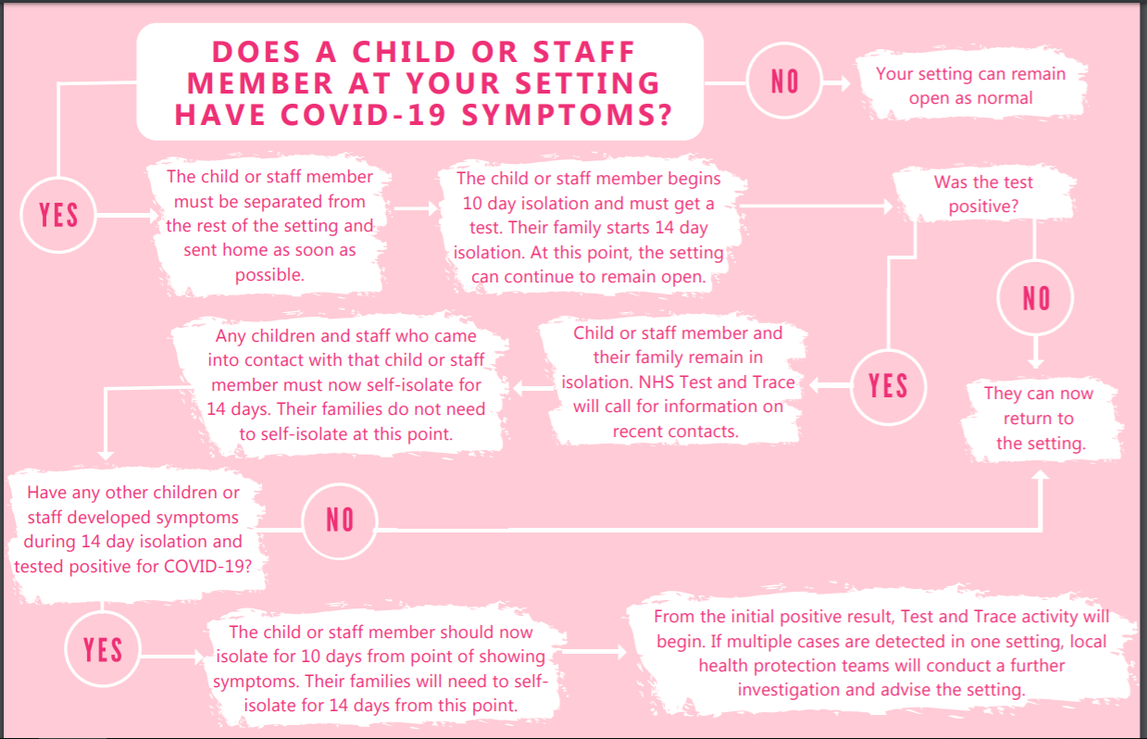

Appendix 2

A child shows symptoms at school
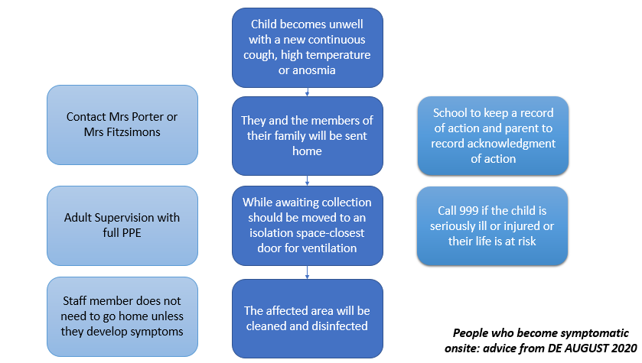

Appendix 3

Instructions if children become symptomatic onsite
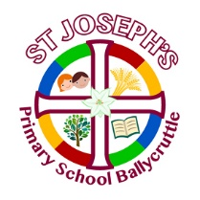
Children who become symptomatic with COVID-19 onsite
Symptoms include
a new, continuous cough or, a high temperature/fever or anosmia (a loss or change in normal sense of smell which can also affect sense of taste)
- Inform the Principal, so a parent can be informed and asked to come to school immediately.
- Staff member will seat the child in the main school corridor and take the child’s temperature.
- Open the front door.
- Wait with the child until the parent arrives.
- PPE is available in the cupboard in the staffroom under the kettle. A mask, apron and gloves are needed and PPE must be worn if direct personal care is needed. However, staff will remain 2m apart if possible.
- If the child needs to use the toilet, allow the child to use the staff toilet. The toilet must not be used by anyone else until it is fully cleaned.
- If the child is seriously ill or injured or their life is at risk, call 999.
- Ask the parent to have the child tested for coronavirus and inform the principal immediately if the test is positive. Inform the parent to follow PHA guidelines and follow the Test, Trace and Protect Strategy.
- Staff member dealing with incident ensures the parent signs the record in the file.
- Mrs Brannigan (if available) to clean any surfaces touched around foyer area and toilet (if used). If Mrs Brannigan not on site, another member of staff to wipe areas down with appropriate cleaning materials.
- Remove any PPE and place in bin, double bag and place in outside designated black bin. Wash hands thoroughly for at least 20 seconds.
- Principal will inform building supervisor who will deep clean the room.
- Building supervisor will sign deep cleaning record when completed.
- Building supervisor will ensure all other areas child has been in contact with will be thoroughly cleaned

Appendix 4 Quick Guide to Coronavirus related absences
What to do if….. | Action needed | Return to school when….
My child has coronavirus symptoms | DO NOT COME TO SCHOOL  Contact school daily  Self-isolate  Get a test  Inform school immediately about test result | The test comes back negative and they are fever free for 48 hours.
My child tests positive for coronavirus | Inform the school immediately about the test result  DO NOT COME TO SCHOOL  Contact school daily  Self-isolate for at least 10 days | They can return to school after 10 days even if they have a cough or loss of taste of smell/taste. These symptoms can last for several weeks once infection is gone. If they continue to have a high temperature they will stay at home.
Somebody in my household has coronavirus symptoms | DO NOT COME TO SCHOOL for 14 days  Contact school daily  Household member to get a test  Inform the school immediately about the test result | Stay at home for 14 days after the first person in your home started having symptoms.
Somebody in my household has tested positive with Coronavirus | Inform the school immediately about the test result  DO NOT COME TO SCHOOL  Contact school daily | The child has completed 14 days of self-isolation
The Track and Trace scheme has identified my child as a close contact of somebody with symptoms of confirmed coronavirus | DO NOT COME TO SCHOOL  Contact school daily  Self-isolate for 14 days | The child has completed 14 days of self-isolation
My child has travelled abroad and has to self-isolate as part of the quarantine process | Returning from a destination where quarantine is needed  DO NOT COME TO SCHOOL  Contact school daily  Self-isolate for 14 days  Provide information to the school as per attendance policy | When the quarantine period of 14 days has been completed
Staff or pupils in my child's bubble have tested positive | Inform the school  DO NOT COME TO SCHOOL  Everyone in the bubble must self-isolate and take a test. | When a negative test is confirmed or the necessary isolation period has been completed.

Appendix 5 What if someone in my house displays symptoms

